EVATT FOUNDATION

MOVING INTO THE OPEN DAYLIGHT - DOC EVATT, AN AUSTRALIAN AT THE UNITED NATIONS

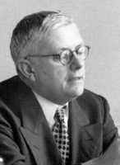

FOREWORD

The Honourable Michael Kirby AC CMG

Dr Herbert Vere Evatt was an outstanding Australian. He was also a highly influential internationalist. As we celebrate the sixtieth anniversary of the acceptance of the Universal Declaration of Human Rights (UDHR), adopted by the General Assembly of the United Nations on 10 December 1948 when Evatt was President, it is fitting that Australians, and all people, should reflect on Evatt's contributions to humanity both at home and abroad.

In his lifetime, Evatt was a highly controversial figure in Australia. The greatest prize to which he aspired, to be elected Prime Minister of Australia, eluded him. Yet in truth, there were few Australians of the twentieth century who stacked up more achievements of lasting benefit to the nation and the world.

A product of the public education system at Fort Street High School in Sydney, Evatt won bursaries to Sydney University and graduated with one of the most brilliant academic records ever attained. He became a brave and imaginative advocate. He was a scholar and writer of lasting importance. He was a scholar and writer of lasting importance. He then became the youngest person ever appointed a Justice of the High Court. In the dark days of War, he resigned as a judge and sought election to the Federal Parliament in a marginal seat. His election led to his serving as Federal Attorney-General and Minister for External Affairs at a critical time for the survival of the Commonwealth. It was in that period that he took a leading part in the creation of the United Nations Organisation, the adoption of its Charter, the establishment of its agencies and the initiation of the UDHR which later became the foundation for the International Bill of Rights.

After he lost governmental office in Australia in December 1949, Evatt's contributions to liberty were not concluded. Against party opposition and all odds, he fought the Communist Party Dissolution Act 1950 in the High Court of Australia. He convinced the High Court to declare the Act unconstitutional. He then contested the referendum that sought to overcome that court decision by amendment of the Constitution. He saved Australia from a serious blot on its liberal democracy. Political passions frustrated, he resigned as Leader of the Opposition and was appointed Chief Justice of New South Wales. From that office he soon resigned, broken and ill and died not long after.

By the time this last appointment came to him, Evatt was already demonstrating mental failure. It was all too evident to the lawyers, including myself, who observed this intellectual giant, deteriorating in the Banco Court in Sydney before their eyes. It was this deterioration that left a painful memory, as enemies and critics circled to assail his reputation. Some of their criticisms were doubtless valid. Especially by the end, Evatt was like Lear: unpredictable, enigmatic, suspicious, disordered. Even at the peak of his powers, his brilliance caused him to work in ways that seemed chaotic to more orderly and pedestrian minds.

Yet as this essay on Evatt's contributions to the post-World War II legal order clearly demonstrates, his heroic work schedule and engagement with so many others, won him deep admiration. More importantly, they contributed greatly to three vital elements of the United Nations system. These were the role within the United Nations of the smaller states, particularly in the General Assembly. The functions within the United Nations of the agencies where most of the good work of the Organisation is done. And the provision to the United Nations of a distinctive moral foundation, in the form of the International Bill of Rights and the Trusteeship Council based upon the fiduciary obligations of equity law that he had learned as a young lawyer. That idea was to bring all the trusteeships of the United Nations to independence by 1994.

What other Australian of the twentieth century can boast of equivalent contributions to the entire world? In the big picture of humanity's survival and the protection of our species from the destruction of conflict, genocide, nuclear proliferation, prejudice and inequality, Evatt's activities on the world stage transcended purely national achievements. The flaws of personality and the chaos of his work methods, the rumpled suits, the vanity, the press clippings and the gravelly voice, fade in memory with the years. It is institutions that people leave and that sometimes survive that become their most lasting human legacies. This monograph shows the importance of Evatt's institutional contributions to the United Nations. Of course, the Organisation is imperfect and it needs ongoing reform. But we have to ask what would have happened if the United Nations had not existed as the forum for the voice of humanity.

When the people of Australia voted down the attempt of Prime Minister R G Menzies to amend the Constitution to afford powers to the Federal Parliament to dissolve the Australian Community Party and place civil burdens on communists, Evatt told his parliamentary party colleagues that it had been more important to defeat that referendum than to win government in a series of federal elections. History suggests that this was a correct assessment. So, equally, it can be said that it was more important in the big picture that Evatt contributed, as he did, to shaping the new world legal order at a critical and vulnerable moment in the history of humanity than that he should have achieved his goal of election as Australia's Prime Minister.

So here is a tale of epic proportions of a man, flawed as we all are, who was an internationalist, a libertarian, a fine lawyer and judge and a most energetic public officer when these qualities were specially needed. With the passage of time his flaws and mortal weaknesses recede in memory and importance. His perception of global institutions and of the idea that an Australian could, and should, play a part in shaping them leaves to us, who are left, a legacy that is inspiring and encouraging for later generations. The global mission that he accepted is by no means complete. But Herbert Vere Evatt left a big mark. Overwhelmingly this was for the benefit of humanity. This essay reminds us of his achievements. They are very great indeed.

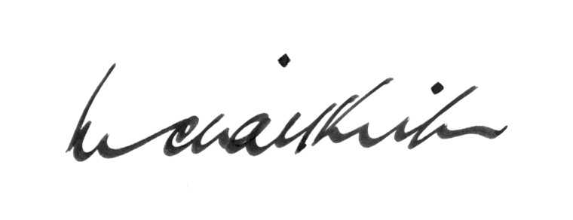

High Court of Australia
Canberra
1 October 2008

EVATT FOUNDATION

MOVING INTO THE OPEN DAYLIGHT - DOC EVATT, AN AUSTRALIAN AT THE UNITED NATIONS

FOREWORD

The Honourable Michael Kirby AC CMG

