PERSONAL BACKGROUND FOR SUE WILLIAMS
Justice Michael Kirby

1. Family background: Both sides of my family came from Ireland - my mother, Jean, from Ulster Protestants. My father, Donald, from Catholics from Limerick. I grew up in a loving, close family in Concord in Sydney. What a beautiful name for a suburb - Concord. My parents were young, encouraging but not pushy. At the age of eight, I had my own desk and studied hard. Like my brother David (now a judge of the Supreme Court of NSW) I went to Fort Street High School. All the brothers (Donald included) became lawyers. My sister Diana is a nursing sister at RPA and works in colo-rectal medicine. We all attended public schools and honour our teachers and the democratic values they taught us. Diana is the noblest one of us all. My mother died in 1998. My father is still alive. He attended my honorary degree ceremony at UNSW this week. Aged 92, he drove from Concord to the University. What is more, he negotiated a parking space, scarce as hen's teeth on the Kensington campus.

2. Getting there: My progress was, like everyone else's, partly dependent on hard work; partly luck; and partly being in the right place when the music stopped. As President of Sydney University SRC, I stood up for Aboriginal scholarships and against restrictions on enrolment of Asian students in the 1960s. This led to me being attacked by media pundits, including the late Eric Baume. This, in turn, brought me to the notice of Lionel Murphy who, for some reason, liked me. This was odd because he was a party goer and I a party pooper. I built a big practice as a barrister, including in industrial cases. Then the late Clyde Cameron appointed me to the Arbitration Commission in December 1974. After this, I received judicial appointments from Labor and Coalition governments, eventually the Keating Government appointing me to the High Court in 1996.

I have also had wonderful support from my staff - my associates, the young lawyers who have worked so hard for me over the last 35 years. And my secretaries. Since I was a young lawyer I have had only 5 secretaries. My current PA, Janet Saleh, has put up with me the longest time - more than 20 years. She deserves the Victoria Cross!

3. Viewing the job: Work on the nation's final appellate and constitutional court is arduous but intensely interesting. Every day is interesting. No reason to fall asleep on the job! Every case is an interesting story, often one in human relationships and conflict. Many cases involve finely-balanced legal puzzles because cases do not get to the High Court unless they are reasonably arguable either way. Like every Australian judge, I am completely independent in performing my duties. And we do our own work, not delegating it to others. There are differences of opinion between us. But that is natural and healthy and transparent in a democratic country like Australia. It is how we make progress in the law and in its values.

4. Responsibility to the public: The judiciary is probably the most open branch of Australian government. Judges always sit in open court. Court doors are very rarely closed in this country. The sad thing is that reportage of what goes on in court is often so poor in Australia. This is a contrast with Britain and the United States and other countries. Here, politics, sport and show-biz dominate the media. Entertainment is the name of the game. At the level of the High Court, law is a story of often clashing values. Such stories could be explained in an interesting way to the public. The judicial reasons lay it all out. But they are sometimes impenetrable and, sadly, in the age of virtual reality and infotainment, the Australian public is poorly served by the media who are often are self-absorbed. In my view, the will of the people of Australia is the ultimate foundation of our law and of our acceptance of our Constitution and legal system. I have a profound respect for the will of the people, usually expressed in laws made by Parliament.

5. Changes to laws: The law has changed greatly in my lifetime - to some extent by judicial decisions which express the common law as in the Mabo case which was before my time on the High Court. Mostly, it is through Acts of Parliament and regulations. Law reform bodies are now fully accepted as essential to an efficient and just legal system. My decade in the Australian Law Reform Commission (1975-84) was highly influential in my thinking as a judge and lawyer. It helped me see the law in context. It also demonstrated the frequent problem of securing parliamentary attention to law reform proposals. This is why many Australians are now favouring a Charter of Rights to help stimulate the law reform and movement towards social justice.

6. Civil liberties: As a young lawyer I joined the committee of the NSW Council for Civil Liberties. Amazing how so many of those committee members in the 1960s later became judges. The anti-establishment joined the establishment. Many, including myself, retained their critical scepticism about law, about its expense, imperfections and weaknesses. It is the right of citizens to be critical of the law and to demand improvement. The culture of civil liberties has improved in Australia over the pasty 30 years. But the advent of anti-terrorism legislation presents new challenges. In most countries such laws are counter-balanced by Bills of Rights. Not so in most parts of Australia.

7. Most memorable controversies: There have been so many controversies over the past thirty-five years that it is impossible to single them out. One close to myself concerned the removal of the criminal laws against homosexual Australians. This reform is now generally accepted. But there are still serious injustices. From the beginning of its modern history Australia has been a society inclined to exclude minorities. The soldiers in 1788 at Sydney Cove tried to exclude the Aboriginals. The convicts were also excluded. Women were excluded from any involvement in government and the design of the federal Constitution. They had no right to vote. Asians were excluded by the White Australia Policy. Gays were excluded and locked up. We have to get over the Australian tendency to exclude. We need to realise that, in our vast continental country, there is room for all of us and diversity is a strength, not a weakness.

8. Any regrets?: Everyone has regrets. I suspect that in my old people's home I will regret so many sunny weekends slaving away in my office over cases and papers. But on the whole, my life has been very lucky. I have certainly been blessed with a loving partner, Johan, and a very close family.

9. Unrealised ambitions: To be the Jerry Springer of Australia. Or maybe Australia's "Larry King Live".

10. Abolishing laws: With the British Empire came a great legacy of laws for a quarter of humanity. Most of the laws were just and the judges uncorrupted. But two of these laws were a bad legacy. One involved the death penalty. The other the law on the so-called "unnatural offences". Those laws still afflict people in most of the countries that were once ruled under the Union Jack. There were no such laws on homosexual offences in most of the French, Dutch, Portuguese and other Empires. Indonesia, for example, with the largest Muslim population in the world, has never had anti-homosexual criminal laws. However, they survive in most of the English speaking world outside the old settler countries (Britain, Canada, Australia, New Zealand and South Africa).

The quality of justice and of human happiness could be greatly increased in our world if all of those laws were repealed and consigned to the imperial scrap-heap. They are irrational, oppressive, against human dignity and wicked. At the Commonwealth Law Conference in Hong Kong in April 2009, I have been invited to talk on this pathetic left-over from the colonial era. Of course, there are bigger problems on earth - global poverty, HIV/AIDS, other diseases, lack of democracy, nuclear weapons, global climate change etc. But the source of oppression for gay people is actually found in the text of laws. So this would be something that could more easily be changed - just as we began the legal changes in Australia in the 1970s led by Don Dunstan and John Gorton. Where change is needed, none of us should forget Winston Churchill's motto: "Never give up".

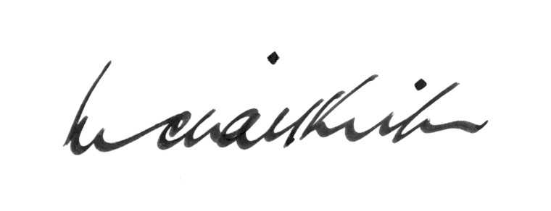

MICHAEL KIRBY

PERSONAL BACKGROUND FOR SUE WILLIAMS
Justice Michael Kirby

