HICKSONS

ALUMNI DINNER, 12 AUGUST 2008

HILTON HOTEL, SYDNEY

LESSONS FOR A LIFE IN THE LAW

Reflections on Years at Hickson, Lakeman and Holcombe (now 'Hicksons')

The Hon Justice Michael Kirby*

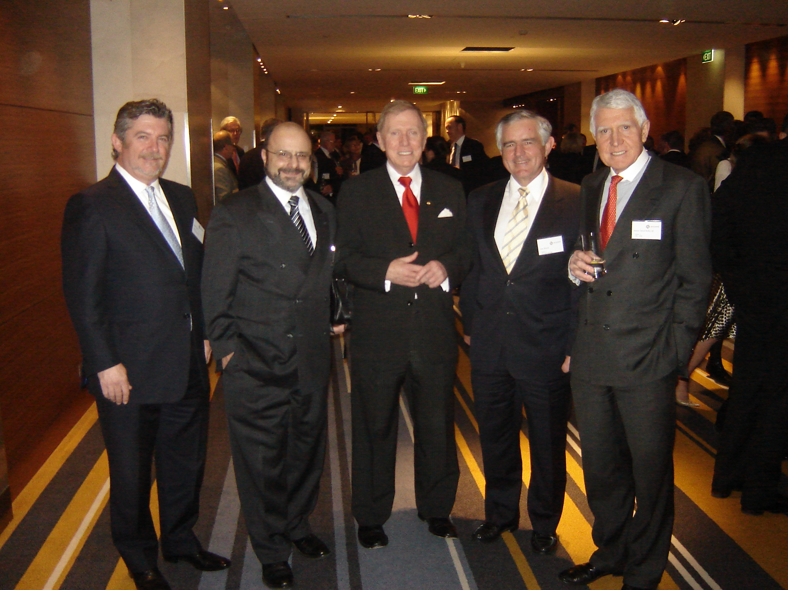
I express thanks to the partners of Hicksons for this Alumni Dinner, for singling me out for special mention and for the attendance of present and past staff, colleagues and friends of Hicksons at this celebration of the values of the Firm.

I appreciate the remarks of my brother, Justice David Kirby, and of Mr James Poulos QC (both past partners of the Firm) in supporting this Valedictory. It is the first of what I hope will be an unending round of functions of unalloyed praise that will accompany me on my way into retirement from the High Court of Australia early in 2009. By force of section 72 of the Australian Constitution, I must then relinquish that office. It is appropriate that this dinner of Hicksons should come first because it was at Hicksons, in its earlier manifestation as Hickson, Lakeman and Holcombe, that I first entered upon professional life as a young solicitor.

I want to identify the professional values that I learned at Hicksons. Basically, they have accompanied me my entire professional life. I will not repeat the rambles and recollections contained in earlier remarks where I have set down my memories of those early days. I was recruited to the Firm following my answer to an advertisement in the Sydney Morning Herald, inviting applications from new graduates for employment as a beginning solicitor. I had expected to begin my professional life at Ebsworth and Ebsworth, a Firm specialising in maritime and admiralty law. However, their offer of a position was unexpectedly withdrawn when Mr Fred Osborne, a partner and Minister for the Navy in the Menzies Government, lost his seat in a general election and returned to Ebsworths, leaving no vacancy for me. I am still getting over the shock of rejection. I indulge in endless speculation about what might have become of my career, if only Mr Osborne had not been rejected at the polls. But Mr Osborne's calamity was my opportunity.

My recruitment by Bruce Holcombe led to me working for him, Roger Lakeman and Charles Spice, the then three partners of the Firm. It eventually led to my promotion to be the seventh partner in the firm's history in 1963. It launched a busy life as a solicitor, in-house advocate and pro bono attorney for university students and the Council for Civil Liberties of New South Wales. My involvement with Hicksons ended in July 1967 when I was admitted to the New South Wales Bar. My first judicial appointment followed in December 1974. Now, at the other end of life, I am approaching retirement. This fact encourages reflection on the journey between. It has turned my thoughts to the chief lessons that I learned at Hicksons. I want to record these so that others can compare the values I learnt with their own experiences.

1. LEGAL EXCELLENCE

Both Bruce Holcombe and Roger Lakeman were fine lawyers. Each was, I believe, a First Class Honours graduate of THE Sydney Law School. Each valued and admired high intellectual standards. In the matter of legal advice, neither was content with shoddy work. Whilst a large part of the Firm's practice involved land title conveyancing and mortgages - with a great deal of routine - Holcombe, in particular, was a stickler for legal accuracy. He knew that, in the law, the devil was usually to be found in the detail. He did not much like barristers, but he made an exception for Trevor Marling, David Rolfed and a very few others who were quick and painstaking in their opinions and agile in court.

In every file that came to the litigation department, I made it my business to prepare a letter of advice. It set out the facts; the applicable law; conclusions and recommendations. In a sense, this was an ideal preparation for the written opinions I later prepared at the Bar and the judicial reasons I wrote in the Court of Appeal and am writing on the High Court. In a legal life, the syllogism is very hard to escape.

Thinking in logical ways about facts, authority, principles and legal policy is the way of life of an Australian lawyer. Of course, intuition, common sense and judgment also play a part. Although I was sometimes criticised for the 'overkill' in my advisings, they reflected the high standards that Lakeman and Holcombe set for the Firm. Even if the clients did not always read the fine print or even understand it, it was the primary file record and it provided an assurance to clients that a lawyer had applied to the task in hand, big or small, the discipline of a lawyerly approach. I never treated good enough as acceptable. Clients came to know this. It was a reason, I believe, that the Firm quickly built up a large clientele, substantially of new insurance companies, with their very numerous and very interesting problems of insurance law.

Hicksons still have an excellent reputation for legal excellence. I hope and expect that they retain a pride in the high quality of their legal advisings. Though appropriate use of the Bar is often wise and prudent, I never accepted a theory that the solicitor's sole function was to point every legal problem in the direction of a barrister. High self-expectation and stringent standards of lawyering constitute an important attribute of the Hicksons tradition.

2. TOTAL HONESTY

Another value that was uppermost in the minds of the partners and staff of Hicksons in my time was the need to exhibit total honesty with each other and with clients and honourable conduct with each other and colleagues in the legal profession.

Back in the 1960s, the legal profession in Sydney was much smaller than it is today. Anyone whose word could not be trusted soon became known. Those who were bullies or who cut corners were added to the mental black-list. I can still remember (but will not name) two prominent legal practitioners who fell within this class. You never forget such things.

Holcombe especially was always insistent on the most scrupulous handling of money; strict adherence to one's word; and careful avoidance of any conflict of interest and duty. He was specially harsh on legal practitioners who were found to have lapsed. Later he served on the Council of the Law Society of New South Wales. Pity help any solicitor who departed from his high standards. Those standards permeated the culture of the Firm.

By the same token, when mistakes occasionally happened (as is inevitable in busy professional lives) candour to Holcombe and the client was the only available policy. In such circumstances, Holcombe would give his colleagues complete support. On one occasion, reviewing my files late on a Saturday evening, I discovered I was out of time for an appeal in a matter where we had instructions to appeal. In those days, time limits in appeals were very strictly observed. I was mortified. But I discussed the matter with Holcombe. We were satisfied that the case was one where the time limit did not affect the cause of action but was only a matter of procedure. We filed our notice of appeal a couple of days out of time. The default was not noticed by our opponent. The matter proceeded to determination on its merits. The circumstances taught me that even conscientious lawyers can sometimes make mistakes. This was a lesson I have never forgotten, throughout my judicial life.

3. HARD WORK AND FOCUS

Devotion to clients, and building up a legal practice requires energy and unrelenting hard work. The client's cause does not switch off at 6 p.m. weekdays During my years at Hicksons, I cultivated a manner of life that has never really left me. I worked extremely long hours and into the weekend to stay on top of the professional challenges.

Both in my work in the Firm, and by observing the barristers whom we briefed, I came to appreciate that attention to detail is generally the way cases are won. For every victory that turns on a skilful argument of law, there are many more that depend on the lawyer's total mastery of the brief and familiarity with the evidence. Superficial generalities rarely win cases. Tricks of rhetoric and eloquence are no match for a complete knowledge and recall of the detail of the provable facts. These were lessons that Trevor Morling, David Rolfe and also the young Neville Wran whom we briefed, taught me in countless unremembered cases.

Holcombe particularly was a stickler for conscientious attention to detail and a devoted attitude to the interests of clients. Repeatedly he would say that we had to help the clients exactly as we would wish to be helped were we in the client's shoes. This was an application to legal practice of the golden rule. It is one that has always stayed with me. I am sure that it is still a golden rule of Hicksons.

4. INNOVATION

Holcombe and Lakeman were also innovators in legal practice:

- Without the benefit of computers, they created a highly integrated legal practice, strengthened by engaging an in-house accountant (Mr Christie) who not only protected the trust account but also ensured the complete financial integrity of all transactions. Legal problems that arose in the course of this practice were streamed off for special attention, usually in the litigation department. That was where I came in. The Firm was extremely modern and efficient in its throughput;
- As well, the long association with Weston Woodley and Robertson (as it is now named), chartered accountants, introduced taxation advice into legal advisings on property transactions in a way that was comparatively uncommon in those early days. Harry Weston was a daily visitor to the Firm. He was a real expert in the taxation implications of client transactions. His firm still act as my chartered accountants and have done so for thirty years. Hicksons were innovators in this integrated approach, at a time when much taxation advice was the exclusive prerogative of chartered accountants to the exclusion of lawyers. Now it is a highly integrated activity;
- The Firm was also a pacesetter in acquiring its own building in the CBD of Sydney. This permitted the reintegration of the general office (formerly in O'Connell Street) and the litigation office (formerly in Castlereagh Street). I have no doubt that moving the two branches into the one building greatly encouraged the later expansion of the Firm. And doubtless the sale of that building in due course secured a handsome profit for the then capital partners;
- Hicksons was also one of the first legal firms to admit a female solicitor to partnership. Yvonne Patterson was an outstanding property lawyer. She was cool, proud and businesslike. I believe that she was only the second woman admitted to a legal partnership in Sydney. Generally, in those days, women were confined to distinctly subordinate roles. Her sister Heather Foley and other women in the practice, including in the support staff, enjoyed huge responsibility. I am thinking of Mrs Bowles and Ms Deidre Collins (now Poole). I would not wish to exaggerate the enlightened aspect of the practice. Holcombe had his old-fashioned side. I remember the day that one experienced and talented secretary attended for work dressed in a neat pant suit. It was the type of outfit that Hilary Clinton and Julia Gillard now wear most days. The secretary was dismissed on the spot. I remember being shocked at this peremptory action. But it can only be understood in the light of the values and conventions of the time. No doubt Holcombe thought he was upholding proper standards of professional dress against the assault of the barbarians;
- Most importantly, from my point of view, it was Holcombe who insisted that I should perform the duty of an in-house advocate. This added greatly to my work burdens. Combining the preparatory work of preparing cases, issuing subpoenas, interviewing witnesses and so forth with court advocacy was a stressful challenge. But it proved highly beneficial for the Firm and for me personally. It won many insurance clients, some of whom (or their successors) remain good clients of Hicksons to this day. Holcombe was ahead of the rest in his concept of solicitor advocates. Now they are much more common. And indeed, some of them have themselves gone on to distinguished judicial service; and
- The Firm was also insistent on using the most up to date equipment. Before the days of computers, that equipment looked extremely antique by contemporary standards. When I began at Hicksons, my dictation machine had rubber belts upon which my dulcet tones were recorded. As Grundig platters and later tape recorders improved the technology, Hicksons were always the first to acquire them. Likewise the accounting machines and early limited IBM memory typewriters were acquired. So were the early wet and imperfect photocopiers. In all such matters, Lakeman and Holcombe were never penny-pinching. They knew the importance of the best technological equipment for the best professional throughput.

5. TIME MANAGEMENT

Working in a growing practice, with a regular supply of tricky legal problems, demanded excellent time management - one of the most important attributes of any professional success. Holcombe had a capacity to discover defects and potential breakdowns in the smooth operation of the Firm. He did this by accepting relatively little actual advising for himself. He was what we would now call a "managing partner". He kept his mind fresh and unencumbered. He read widely, including in the law. He was always available and interested. Sometimes Holcombe would intrude into my office to find what was happening. But generally he had the gift of leaving it to trusted staff to work their own way through their cases and files. In addition to conscientious employees, successful legal firms today need trouble-shooters whose desks are relatively free and who can move in to give support when that is needed. Such trouble-shooters tend to be found at the very top and the very bottom of the hierarchy.

I have paid tribute to Holcombe in this respect. I would also want to mention the outstanding articled clerks who worked in the litigation department, many of whom have gone on to important legal careers of their own - my brother David Kirby, Jim Poulos, John Bagnall, the Hon Bob Debus, Ian Bullock, Alan Boulton, Bruce Odling, Allan Osburg and Alan Blanch. Learning effective time management is one of the most important challenges for everyone in the legal profession. The successful pursuit of legal practice depends upon it.

6. GENEROSITY

Holcombe and Lakeman were, in some ways, tough task masters. But they were also extremely generous. They rewarded devoted work.

When, after about a year of service in the Firm, I was presented with the opportunity to travel to Nigeria, Ghana, Malaysia and Singapore for the National Union of Australian University Students, I tendered my resignation to Holcombe. He rejected the proffered resignation out of hand. He insisted that I proceed on the journey. Indeed, he said that he was glad that I had such an opportunity. Moreover, he insisted that I return to Hicksons; promised appointment as a partner on my return; and give me a letter of credit in the sum of £1,000 as a bonus, to spend as I wished. He also provided additional credit so that the journey would both be successful and enjoyable. This was totally spontaneous. It was unexpected; but it won devoted loyalty from me.

Holcombe was also encouraging of my postgraduate study towards the BEc and LL M degrees, activities in the Students' Representative Council of Sydney University and as Honorary Solicitor for the students. That was not a small burden because these were the times of the Vietnam War, of protests, of applications for exemption from National Service on grounds of conscientious objection and many civil liberties cases. Hicksons has always performed a substantial amount of pro bono legal advising. When I arrived, Holcombe had long been acting at little or no cost for the Legal Service Bureau, a body that gave advice to returned servicemen. He was himself proud without boasting of his war service. In this respect he was a typical Australian. He was happy to see gratuitous work expand for university students and civil liberties causes.

Although Holcombe sometimes tended to a gruff, conservative attitude, suspicious of libertarian causes, he was actually strongly interested in them. And so was Lakeman whose wife, Vida, was an artist and also a most accomplished and civilised person. Holcombe's wife, Jean, was a homely person who generally kept him under control. These two men expected a lot. But they gave a lot back. I trust that this is still the ethos of the Firm.

FUTUROLOGY

In many ways, Holcombe and Lakeman looked to the future. They established a Firm that, I its time, was creative in significant and unusual ways. It became a kind of training ground for many of the leading lawyers of Sydney and Australia. One of them, Danny Gilbert, went on after an interval of work as a clerk at Hicksons, to establish his own very important Firm, Gilbert + Tobin - one of the most innovative in Australia. The spark of innovation and of thinking freshly was part of the ethos of Hicksons. Danny Gilbert, like Holcombe and Lakeman, has always been willing to support worthy communal activities, especially as they concern Aboriginal Australians and other disadvantaged groups.

Hicksons offers summer clerkships with good rotations. It provides ongoing mentoring and coaching. It addresses a good work/life balance. All of these innovations are new since my day. It can safely be said that no one would be dismissed today for turning up in a pant suit. Males do it all the time.

Getting the right work/life balance is a big challenge in the contemporary Australian legal profession. When, soon after my appointment to the High Court of Australia, I attempted to challenge the Australian judiciary to consider the issue of stress, my efforts were resisted and even mocked and decried in some quarters. We now appreciate more clearly the imperative need to maintain a good work/life balance in the legal profession. I was therefore particularly glad to read in a recent journal that Hicksons place an emphasis on work/life balance; and on sporting and gymnastic engagement of staff. Many of these steps are new. They represent a venture into the future and an acceptance of a need to move with the times and with new knowledge.

Increasingly it is appreciated in the Australian legal profession that a fine line exists between respecting the privacy of individuals and exhibiting complete indifference to their lives when they face crises of confidence. Stress, depression, breakdown in personal relationships, addiction and even suicide are features of the life of sufficient members of the legal profession (including the judiciary) for us all to be concerned about it. Fortunately, there is now much more candour about these topics. I am glad that Hicksons are engaging in addressing these questions.

A lawyer who is supported professionally and personally is more likely to offer successful and insightful professional advice. Just as importantly, that lawyer will enjoy happiness and fulfilment in the law, which is still, at its best, one of the noblest occupations that a human being can pursue. I have been fortunate over forty years in my life partner and I owe much of my achievement to his steadfast loyalty and support. So it is with most lawyers and Firms do well to recognise this.

I conclude as I began with words of thanks for the honour of this occasion and for the attendance of so many old and new friends. By remembering the past, we are sure that the future will be built on firm foundations. Roger Lakeman and Bruce Holcombe would be very proud if they were here to see the progress made by their Firm. The greatest tribute that we can pay them, in our professional lives, is to live up to the values that they established.

HICKSONS

ALUMNI DINNER, 12 AUGUST 2008

HILTON HOTEL, SYDNEY

LESSONS FOR A LIFE IN THE LAW

Reflections on Years at Hickson, Lakeman and Holcombe (now 'Hicksons')

The Hon Justice Michael Kirby

* Justice of the High Court of Australia. Partner of Hickson, Lakeman and Holcombe, 1963-1967.
See M D Kirby, "Memories of Hicksons", unpublished talk at the celebration on 8 May 2002 of the 50th Anniversary of the founding of the Firm on 1 April 1952; and "Memories of Hickson, Lakeman and Holcombe", an essay on life as a solicitor in the 1960s published, in part, in the Journal of the Law Society of New South Wales.
M D Kirby, "Ten Parables for Freshly-Minted Lawyers" (2006) 33(1) The University of Western Australia Law Review 22 at 25.
(1997) 71 ALJ 774, 791.
Lawyer 2B (11 June 2008), 12.
Geoff Gibson, "Does the Bar Matter?", Victorian Bar News, Autumn 2008, 57.

