ALZHEIMER'S AUSTRALIA
DEMENTIA, LESBIANS AND GAY MEN
Foreword
Justice Michael Kirby

In the past, Australian gay men and lesbians, bisexuals, transsexuals and other members of sexual minorities (GLBTI), commonly hid their sexual orientation. This was a burden on their relationships with their birth families, their neighbours, their work fellows and the world at large. There was a rule to live by: 'Don’t ask. Don't tell'.

The result of that rule was sometimes that members of sexual minorities were absorbed, more or less, into the majority heterosexual population. Some even married and had children, although their relationships frequently suffered because of the internal conflicts. Others pretended, although frequently observers of their lives would whisper behind their backs and often in a nasty and critical way.

Fortunately, the twentieth century witnessed a rise in enlightenment. This came about, in part, through science, following the research of Dr Alfred Kinsey and others into human sexuality. And, in part, through changes to the law reflecting and stimulating changes in social attitudes, many of them coming about following the Wolfenden Report in England in 1957. Science and law can change as much as they like but attitudes of prejudice will frequently remain. Sadly, some such attitudes of prejudice are caused by religious instruction. Fortunately, this too is changing in many quarters.

The first generations of Australians who lived through the new discoveries of science and the changes of the law and social attitudes, are now arriving at the ages when problems of dementia and Alzheimer's Disease begin to affect members of the human family. These conditions do not discriminate. They fall equally upon heterosexual, homosexual and bisexual people.

Some things are new. Most people in Australia are living longer. Australia's population is ageing, with all of the health consequences that this produces. As well, many of those now beginning to face problems of dementia and Alzheimer's Disease, represent the first generation of people living openly, or semi-openly, without shame or undue fear because of their minority status. Law reforms are being proposed and adopted to remove many of the residual legal disadvantages faced by sexual minorities. However, discriminatory attitudes and some discriminatory laws still remain. Alzheimer's Australia is to be congratulated for examining the particular impact of dementia and Alzheimer's Disease on GLBTI minorities.

It may be hoped that, in the future, many of the problems described in this paper will be removed as prejudicial social attitudes and discriminatory laws give way to more just, equal and accepting approaches to members of the GLBTI minorities. In the meantime, our society has a number of problems on its hands. Some of these arise because of injustice in the law. Some derive from the predominant role that religious organisations play in many retirement and health facilities. Yet others exist because of residual fears in the minds of GLBTI people, left over from the times in which they grew up. This paper seeks to address all of these concerns and to do so in a short, readable account of where the problems lie; what can be done about them; and who can be contacted to help those in special need.

Special needs may be traced to the much higher levels of loneliness suffered by sexual minorities. One figure in this paper suggests that 46% of GLTBI people in Australia live alone, as compared to 23% of the general population. Living alone is specially difficult for a person facing a journey into dementia and Alzheimer's Disease. Having no children or supporting family can also make the predicament worse. But even for those who live with partners, the problems of making wills, protecting superannuation entitlements, demanding human respect and showing human affection present difficulties addressed in this paper.

It is a mark of the improvement in our society that the present investigation has been undertaken. Packed into its few pages is a lot of wisdom and practical advice. In a sense more importantly, there is also kindness, acceptance and a recognition that we are all basically one. True spiritual values require that we recognise and respect this fact and accept that people are different in various respects - in gender, race, intelligence, beauty and also human sexuality. Yet these differences are insignificant beside the features we share in common. And in today's world, those features include the challenges of dementia and Alzheimer's Disease.

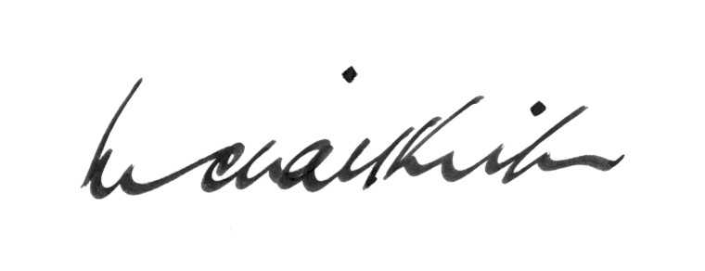

High Court of Australia Michael Kirby
1 October 2008

ALZHEIMER'S AUSTRALIA
DEMENTIA, LESBIANS AND GAY MEN
Foreword
Justice Michael Kirby

