SUPREME COURT OF NEW SOUTH WALES

Court of Appeal

19 NOVEMBER 2007

ON THE PRESENTATION OF A PORTRAIT BY JOSONIA PALAITIS

The Hon Justice Michael Kirby AC CMG

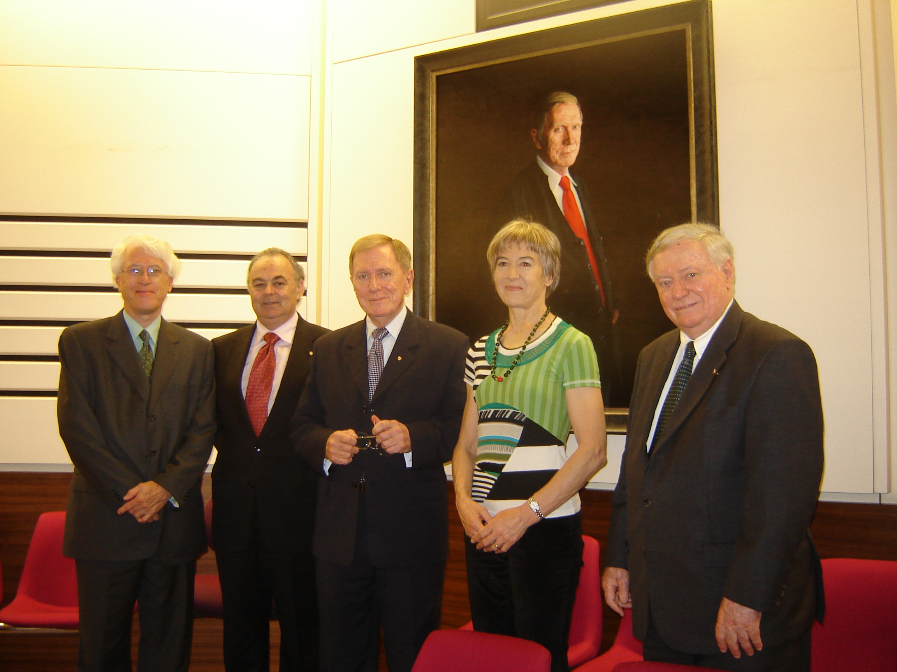

Mason P, Spigelman CJ, Kirby J, Ms Jo Palaitis and the Hon D L Mahoney AO QC
THE CENTRAL SEAT

I approached this courtroom, as humility required, from the public lifts. Judges forget what it is like to walk into a courtroom though the main doors. Normally, like an apparition, they appear and disappear from public and professional view through the doorways leading from their chambers. After such a long absence, it somehow seems strange, and a little alien, to approach a room in which I spent more than a decade of my working life, from the public space. But now I am back in my old seat.

Actually, the public entrance is the best perspective of the new portrait in the President's Court of the Court of Appeal where it will now be displayed. It is an image of myself that will stay when I depart again. A reminder will be left here of the busy years that I spent as President of the Court of Appeal of New South Wales.

I admit that I feel very comfortable resuming the central seat in this courtroom. It is generously vacated for me by Chief Justice Spigelman and by its usual occupant, Justice Keith Mason, the present President of the Court. I am honoured to be sitting with them on this Bench and to have sitting with me, on my right not only the artist, Jo Palaitis, but also the Honourable Dennis Mahoney who was my colleague throughout my eleven and a half years in the Court of Appeal. He was also my successor as President.

How often we sat together, as we now do. Amazing how familiar it quickly seems. I express thanks to Dennis Mahoney for his generous words in 'launching' this work and for allowing prudence and kindness to triumph in his remarks over candour and accuracy. Others have mentioned, on earlier occasions, the new era of civility in the relationship between the Court of Appeal and its advocates and the consensus we built in the relationships between the judges. They were happy times. I am therefore glad to return. This is a public occasion that I am determined to enjoy.

WITH THANKS AND PRAISE

I express thanks for the completion of this project and to all who have contributed to it. There was an earlier proposal to acquire a portrait of me, to hang in this courtroom. That portrait was by a young Australian artist, Ralph Heimans. It was large and impressive work. I liked it. Unfortunately, the guardian of all things artistic, Justice R P Meagher, vetoed it. So the portrait was rejected only to be snapped up by the National Portrait Gallery in Canberra. It is now an addition to that gallery's collection. Ralph Heimans has gone on to fame, and I hope fortune, as the painter of the Crown Princess of Denmark for the Royal Portrait Gallery in Copenhagen and other notables here and overseas.

It was on a visit to the National Portrait Gallery, now constructing its new building on the perimeter of the High Court in Canberra, that I saw Jo Palaitis's portrait of Mr and Mrs John Howard. It is an impressive work and a very good likeness. In my opinion it is to the credit of Mr Howard that he chose to be represented in the portrait with his wife. Fortunate is the public figure who has a supportive partner and companion in life. Seeing this work led me to contact this fine artist. She had executed a portrait of me fifteen years earlier. She proposed another portrait. I agreed. The result is now hanging in this courtroom.

To have the portrait in this public building required initiatives from on high. Chief Justice Spigelman saw this portrait amongst the finalists in the 2006 Archibald Prize competition in Sydney. It was his idea to acquire it for the Supreme Court of New South Wales. I express thanks to him for his endorsement of the proposal and for his initiative in turning the idea into actuality. It was a generous gesture. In all probability, nothing would have happened but for his support.

I also thank Justice Mason and his present colleagues, many of them present, for acquiescing in the proposal to display the portrait in the principal courtroom of the Court of Appeal. It is one thing to hang portraits of judges long departed amongst the currently serving judges - such as the portrait of Chief Justice Jordan and the portrait of Mr Justice Sugerman, already hanging here in the President's Court. Both of these were added long after the subjects had died. The difficulty with intruding contemporaries is that we all know only too well their faults and foibles. They are more vivid in the minds of their colleagues than anything even a considerable artist can capture on canvas or linen.

So I thank the present Judges of Appeal for their forbearance in permitting my "return" to this room. I ask them to look past the faults and blemishes of the subject and to see the hanging of this portrait as a step in recording properly the images of the personalities who have contributed to the life of the Court of Appeal. We in the law know how important it is to preserve and remember history. However, I do appreciate that it becomes much easier when the dramatis personae have permanently departed the scene and gone to their reward - a sacrifice that I was not presently prepared to make.

It was my own Bar, through the New South Wales Bar Association, that agreed to Chief Justice Spigelman's proposal to acquire the portrait. I suspect that they needed a three-line whip to raise half the funds needed for the acquisition. I am grateful to the then President of the Bar, Mr Michael Slattery QC, whose distinguished service as President has just ended. So many times, at the Bar, I fought battles against his father, the Hon Jack Slattery, later a judge of the Supreme Court. I sat with him many times in the Court of Criminal Appeal. I am grateful to Michael Slattery for endorsing the acquisition of the portrait and for bringing it to pass. I also appreciate the presence of Anna Katzmann SC, the new President of the New South Wales Bar. She appeared before me in this courtroom, early in her life as a barrister. We both survived. I now ask her to convey my thanks to the members of the Association who contributed to the cost of the portrait.

I also express thanks to the Law Society of New South Wales for providing the other half of the cost. I would mention especially Ms June McPhie, President of the Society at the time. I spent seven years as a solicitor and member of the Society. I have had many associations with it. So I appreciate the generosity of the solicitors that has meant that the acquisition of this portrait has become possible.

FAMOUS COLLEAGUES

Returning to this seat, the memories of past colleagues come flooding back. In September 1984, no sooner had my welcome ceremony concluded, but Chief Justice L W Street bade me farewell, for I was rostered to sit, an hour later, in this courtroom. On my right, was Hutley JA, with a little more than a month to serve before his retirement. On my left, was Hope JA.

I was glad to sit with Hutley JA, for he was a very considerable intellect. He had taught me the law of succession at law school. I hosted a lunch for his retirement and captured a fine photograph of his personality: a combination of shyness, inquisitiveness and combativeness. I have presented a copy of the enlarged photograph to his family. It is fortunate that I took so many photographs during my years in the Court of Appeal. Eventually, I hope, they will find their place in a proper history of this most distinguished Australian appellate court.

Hope JA was a noble spirit. He had every reason to expect that he would be appointed President in succession to Moffitt P. When I was chosen, he never let his disappointment show. It was a taxing time for a young judge to sit with such very experienced colleagues. Hope JA became a fine mentor. We developed a good friendship which strengthened with the years.

Also present in the Court in those early days was Glass JA who, as Harold Glass QC, had led me in many cases at the Bar. He was another most gifted judge: precise, cultivated, sharp. He often welcomed me to his home and took an almost paternal interest in my development.

Another great judge of those times was Samuels JA. He had been an elegant leader of the Bar and became a most accomplished judicial performer. No one could deliver ex tempore reasons with such grace and persuasiveness. His contributions extended to legal education and, after his judicial retirement, continued as Governor of the State. As I sit here, he and all those fine judges are with me in spirit.

Dennis Mahoney, who has officiated today, also led me in many cases at the Bar and occasioned the move of my chambers so as to be close to him and his huge practice. His instruction continued when we sat together in this room. I would see him writing notes during argument. Whilst always vigilantly alert to argument and searching in his questions, already, he appeared to be planning an outline of his reasons for judgment - setting out the main headings of possible future drafts. He taught me that court sitting time is working time. Judges must be multi-skilled. They must be able to test propositions orally but, at the same time, plan their possible responses. He was also unfailingly courteous to counsel. I express gratitude to all these fine men (for at that stage there were no women) for their instruction and guidance.

Priestley JA, and soon to join us, McHugh JA were the younger judges of the Court of Appeal. They were both lawyers at the height of their professional powers. They reflected an element of generational change and some differences of values. It was a very strong court. I was proud to be a part of it.

Soon the Court was further strengthened by the appointments of Clarke JA, Meagher JA and Handley JA, all of whom became friends. Handley JA, with Michael McHugh, had the most encyclopaedic knowledge of the cases and the principles. I am grateful to the Hon Kenneth Handley for attending this ceremony. He is still serving as an Acting Judge of Appeal and is thus a continuing judicial link to the court of those halcyon days. I also appreciate the presence of the Hon Simon Sheller, a most outstanding judge. Other judges came and I served with them in this courtroom. Throughout the years I also worked closely with Street CJ with whom I shared many values. Our friendship strengthened with the years.

I am particularly specially grateful to my colleague Heydon J for joining me today on this sentimental journey. In our service in the High Court, we both know how fortunate we were to have participated as judges in this outstanding court. There is no finer training ground for such service in Australia than in this courtroom.

I acknowledge the presence of many other current judges of the Court of Appeal from later and present years. They are continuing the same high tradition. Also here are judges of the Supreme Court, including some who served on the court at the same time as I. It is a singular honour that the Hon Jeffrey Miles, who later became the Chief Justice of the Supreme Court of the Australian Capital Territory, has returned to Sydney for this occasion. In a photograph of my welcome ceremony for the Court of Appeal, that still adorns my chambers' wall, he and Hodgson JA are portrayed - they have been good companions on the judicial journey. To the Chief Judges, Judges and Associate Judges, former Judges and legal practitioners present at this ceremony and to those who contributed to its arrival, I express my thanks.

I have left to last my brother David Kirby who continues to link our family name to the Supreme Court of New South Wales. Now, through this portrait, although I am gone, I feel that I too will remain present in the Court. In years to come, judges, advocates, litigants and members of the public, who did not know me, will stare at the portrait. Doubtless most will wonder who that old man was and what he is doing here.

On his retirement, Hope JA told a capacity crowd in the Banco Court that his associate had made a pertinent remark to him as he prepared to depart. The young man confessed that he had come to his tasks with an expectation of finding on the Bench of the Court philosopher kings puzzling over the great issues of justice and ethics. Instead, he had found a group of serious elderly lawyers striving to reach just and lawful conclusions. For Hope JA, that description was a badge of honour. So it is for me and should be for all of us.

THE NEW PORTRAIT

I come, at last, to the most important person present at this ceremony. I refer to the artist, Josonia Palaitis, who laboured many months to achieve a likeness of appearance and personality in the portrait we now witness.

When I revived my friendship with her, we discussed the development of her art since our earlier encounter. She taxed me on the features of portraits that I liked. I described to her a portrait of a Spanish judge by Goya, that hangs in the vestibule of the Rijksmuseum in Amsterdam. With my partner, Johan, I had discovered that portrait in 1969. I found it enigmatic and fascinating.

The reason for this mysterious quality was revealed in the Museum's notes on the work. Goya adhered to a theory that a portrait should demonstrate the two sides to human personality, present in the subject's face. According to this theory, one side of the face typically reveals softness and kindness. The other harshness and reality. In his portrait of the Spanish judge, Goya put his theory to work with powerful effect. So, I believe, has Josonia Palaitis. Judges, striving for justice, will often attempt to be kind and just, so far as they can be. Yet in the same moment they are often obliged to do harsh, strong and punitive things on behalf of society. They must tell the truth as they see it. They cannot delegate unpleasant tasks to others. Law and justice sometimes struggle with one another. The human subject must resolve the tension. Little wonder if the faces of judges reveal the struggle.

In Goya's portrait, the subject wears a bright red cummerbund. Introducing that vestment into the apparel of the President of the Court of Appeal was an idea that I occasionally toyed with. But I resisted. So, for the portrait, I wore a tie of the same red colour. I discovered that for Jo Palaitis, what was most important was conversation with the subject. She needed to burrow under the skin and to understand the relationship of the individual with the world to which the face looks out. When speaking with her, I noticed the strange stare of the artist. It is an unsettling and unremitting gaze: a kind of opaque examination, sharper than that of any judge that I have seen. It appears to express an extra genetic gift.

I knew from Jo Palaitis's other works that she is usually happiest with light, colour and bright objects. I warned her that "lawyers love black". "Put more black into it", I repeatedly urged. Eventually, the portrait emerged: dark and sombre with a Goya-like luminous blackness. It makes me look somewhat more angry and forbidding than I ever felt when working in this room. But, doubtless this will only make the lawyers and litigants of the future more appreciative of the kindly dispositions on the living judges before them.

To the Chief Justice, the President, my judicial colleagues, and friends from the legal profession, past and present, those who contributed to this acquisition, family and all present I express my thanks. I am glad that I have followed Lord Denning's footsteps in returning to the Court of Appeal. It was where I was happiest. But, unlike him I will quickly depart. I will leave this seat, almost certainly for the last time, with reluctance. Yet I leave an image and some ideas behind.

SUPREME COURT OF NEW SOUTH WALES

COURT OF APPEAL

19 NOVEMBER 2007

ON THE PRESENTATION OF A PORTRAIT BY JOSONIA PALAITIS

The Hon Justice Michael Kirby AC CMG

