NEW SOUTH WALES SOCIETY FOR COMPUTERS AND THE LAW

STRANGERS' DINING ROOM, PARLIAMENT HOUSE, SYDNEY

TUESDAY, 9 OCTOBER 2007

COMPUTERS & LAW: THE FIRST QUARTER CENTURY

The Hon Justice Michael Kirby AC CMG

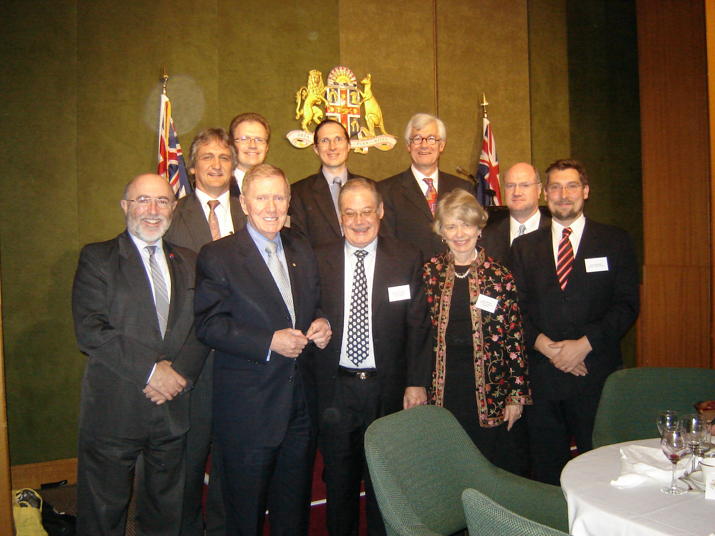
Justice Michael Kirby with members of the NSW Society for Computers and the Law

PRESENT AT THE CREATION

My association with the Society for Computers and the Law arose, in W S Gilbert's immortal words, out of a set of "curious chances". Without delving too deeply into Erwin Schrödinger's theories of quantum physics, and the interrelationships of everything in existence, it will suffice for my purposes to say that I became involved with the Society because George Orwell, long before, had written his book 1984. In that book, famously, he predicted the dangers of the world of Big Brother, with control by the powerful over the sources and flows of information.

With the advent of popular computers in Australia in the 1970s and 1980s, it became necessary for the government to address the legal and social consequences. Like an icon, the year 1984 stood as a warning. It demanded a timely response. Appointed to chair the Australian Law Reform Commission (ALRC) in 1975, I was in the right place, at the right time, to assist government respond to the challenge. On the election of the Fraser Government at the end of 1975, the new Attorney-General, Robert Ellicott, asked the ALRC to prepare a report with advice on the ways in which federal legislation in Australia should respond to the issues of the new age.

This forward-looking project coincided with investigations by the Nordic Council of the Scandinavian nations, the Council of Europe, the European Communities and the Organisation for Economic Cooperation and Development (OECD). Each of these bodies investigated the legal response to the processing of information through automated systems. In 1978, at its headquarters in Paris, the OECD established an Expert Group. This Group was convened to provide Guidelines for the advanced economies of the countries in the OECD on the issues presented by transborder data flows. Because of the project on privacy protection upon which the ALRC was then working, I was sent to Paris to participate in the Group. Because of my pleasing personality, and the relative powerlessness of Australia in the resulting policy struggles between the United States delegation and the delegations from Europe, I was elected chairman of the Group.

It was the OECD Expert Group that developed the OECD Guidelines on Transborder Data Barriers and the Protection of Privacy. It was a notable achievement. The OECD Guidelines, published in 19890, provided an outline of basic principles that should guide the developed countries in responding to one of the main challenges presented to democratic societies by information technology. Moreover, it did so in terms of broad principles which the countries could agree upon, despite their differing legal systems, so as to minimise the application to common technology of discordant regulations.

This exercise was an eye-opener for me. It assisted the ALRC in the preparation of its report on privacy protection in Australia. The recommendations in that report dealt with a wide range of issues concerning privacy protection, beyond the newly emerging technology. Yet the centrepiece was a response to the protection of privacy in the context of informatics. We were in the midst of our work on that project, and the application of the OECD principles, when this Society was formed in Sydney. It was perhaps natural that I should be invited to participate in the inauguration. Ever since, I have been privileged to be associated with the activities of the Society, which has gone from strength to strength.

At the time the ALRC was working on privacy protection, Attorney-General Ellicott addressed the Commission with a different technological challenge. I refer to biotechnology. The ALRC was mandated to report on the ways in which the law should be adapted to deal with the new problems presented by human tissue transplantation. In due course, the ALRC report on that topic was delivered. It recommended laws on human tissue transplantation for the Australian Capital Territory. In due course, laws, based on the ALRC model, were enacted in all parts of Australia. A little later federal laws were also enacted to give effect to the ALRC report on privacy protection.

In thinking about the principles that should be expressed in these laws, the inter-relationship of the underlying technologies became clearer. Indeed, as Schrödinger's theories had hinted, all of the great modern technologies were inter-related. To win the Second World War, the Allies developed the atomic bomb based on nuclear fission. To produce the rockets that could deliver or threaten this fearsome technology, miniaturisation in the form of computers and microchips had to be developed. And when this happened, automated analysis of complex biological material became possible. This, in turn, helped to unravel the puzzles of the human genome revealed just a few years earlier by Watson and Crick.

In this way, the three major technologies of the second half of the twentieth century could be seen in their inter-relationships. Now, a further technological advance is occurring, in the form of nanotechnology. Still further changes will take place. Many of them will have significance for society and for its laws. But they will all be interrelated.

Because the technologies themselves have now gone beyond the understanding of ordinary citizens, even highly educated ones, it is essential that society should be able to look to experts in the technology to help in defining, and responding to, the implications for society of the technological advances. This is where bodies concerned with computers and the law, and with biotechnology and the law become so important as contributors to the democratic institutions of society. It is where law reform commissions and expert bodies, drawing upon such organisations, can play such a useful role in assisting lawmakers and officials in the design of new laws. I acknowledge the part that the Society for Computers and the Law , whose first quarter century we celebrate, has played in the work of the ALRC and in public dialogue generally. I am sure that this will remain an important role of the Society in the years ahead.

A SPECIAL DIFFICULTY

The ALRC report on privacy gave birth to the federal law on that subject in 1988. In Schedule 3 to that law was contained a series of "national privacy principles". As the Privacy Act declared in its Preamble, its purpose included that of ensuring Australian compliance, as a member of the OECD, with the recommendation of the OECD Council which urged "that member countries take into account in their domestic legislation the principles concerning the protection of privacy and individual liberties set forth in" the OECD Guidelines. The Privacy Act recited that Australia had "informed that Organisation that it will participate in the recommendation concerning those Guidelines". It was in this way that the OECD Guidelines came to be reflected in Australian national law as, indeed, in the national laws of New Zealand, the Netherlands, Japan and other member countries of the OECD.

One of the principles, reflected in the OECD Guidelines, was the so-called "use and disclosure" principle. Essentially, this required that, where personal information concerning an individual was provided for use by another, such information should, as a matter of general principle, not be used for a purpose different from that for which it had originally been provided without either (a) the consent of the data subject or (b) specific authority of law. At the time this principle was expressed, it was a sensible and beneficial one. It was designed to ensure that information would not haemorrhage in ways that spread, far and wide, personal information about an individual. It appeared a proper response to the information technology of 1978-9. It was reflected in the OECD Guidelines and in the Privacy Principles contained in the Australian Privacy Act.

A difficulty quickly arose with the invention of search engines, including Google and Yahoo!. Their capacity to search automated data for purposes that had not been identified to the data provider (or even known or conceived of by the data subject or provider at the time of supply) revolutionised the capacity of automated systems to supply information by reference to purposes different from those existing at the time of the collection. The technology, in effect, bypassed the principles. The specification of the purposes of collection and the limitation of use and disclosure by reference to such purposes went out of the window. The huge practical utility of the capacity of search engines to benefit users and to expand the utility of information in their collections, made it impossible to adhere to the old principle.

In practical terms, there was no way that the use of search engines could be forbidden. Their utility was far too great. Something had to give. In the end, what gave was the principle expressed in the earlier days of the more primitive technology. This example illustrated vividly the need for the law on these subjects constantly to adjust, and to take account of, advances in technology. Laws that fail to do so would quickly be viewed as out of date, irrelevant and counter-productive.

There are many illustrations of this need to keep the text of laws in harmony with advancing technology. For example, the Criminal Code (WA) originally contained references to provisions requiring that confessions and admissions to police, by suspects in police custody, should be recorded on "videotape". The change of recording technology from tape to digital formats necessitated amendment of such laws to substitute the requirement for "audio-visual recording". The statute book is now full of examples of this kind where past technology is discarded and substituted references are necessary. This is true in areas of computers and the law. It is equally true in relation to the law as it affects biotechnology.

To the extent that the legislature writes technology into a statute, it runs the risk that the technology will be overtaken by new technology. It therefore confronts the problem that the use of technological language in a statute may quite quickly become inappropriate for the developments in the technology that occur soon afterwards.

As further problem that democratic societies often face is that democratically elected legislatures are not always interested in subjects such as computers and the law. Often there are no votes to be gained in tackling such issues. The subject does not constitute a sexy area of the law. It is not one likely to attract a lot of attention and interest, let alone votes for hard pressed politicians. It therefore tends to be neglected; left alone. If a subject of the law is neglected, we all know what that means. There is never a gap in our system of law. Problems upon which Parliament has refrained from speaking come to people like me in courts like the High Court of Australia. Such courts endeavour to develop new principles by analogical reasoning from the principles stated in old cases.

WHAT HAVE WE LEARNED?

It is appropriate to ask the question: what have we learned in the past quarter century since the NSW Society of Computers and the Law was founded? What are some of the lessons to be derived from our experience, as lawyers, addressing the impact of new information technology upon our discipline, the substance of its rules and the way it is practised?

First, in the early years, we had to get by without established experts. When the new technology came upon the law, there was no body of doctrine, and few analogies, for tackling the issues that computers presented. Even now, two decades later, there are relatively few experts. This makes the drafting of regulations difficult, for the drafters often have little understanding of the working of the technology. Moreover, sometimes the courts have little insight into technological concerns.

The necessity to go back to basics can be demonstrated in two decisions of the High Court over the past twenty years. These are Computer Edge Pty Ltd v Apple Computer Inc and Stevens v Kabushiki Kaisha Sony Computer Entertainment. The latter case concerned a claim of breach of a "technological protection measure", installed by Sony Corporation in the programme for its computer games. Sony asserted that the measure was protected under the Australian Copyright Act 1968 (Cth). It argued that Mr Stevens had unlawfully circumvented the device. In the result, Sony lost. But the case demonstrates the high technological specificity of legislation in this field. The novelty of the problems presented illustrates once again V I Lenin's aphorism that it is the person who writes the minutes of an organisation who usually ends up controlling it. Those who have written the early regulations and decisions on computer law have, to some extent, been engaged in self-fulfilling prophesies.

Secondly, we have learned that a failure to provide law to deal with consequences of new technologies is not always socially neutral. Effectively, the failure to intervene often involves an effective decision upholding the direction in which the technology itself has taken society. The early laws on human tissue transplantation, surrogacy arrangements and now cloning attempt to chart the boundaries within which technology will advance. In default of legislation, court decisions will often draw the boundaries, effectively writing them on a blank page. Where such court decisions are deemed unacceptable, for whatever reason, they may provoke amending legislation. Pursuant to the United States-Australia Free Trade Agreement, this is what happened following the High Court's decision in the Sony litigation.

Thirdly, in the field of computer law, we have come to realise that there is often a tension between regulation of the technology designed to uphold the interests of technical innovators and other legislative and competing interests in society, including consumer rights and rights to free expression. Such tensions are the subject of intensive examination in the United States. Professor Lawrence Lessig, for example, has frequently expressed concern about the balance that is being struck between rights to private copyright protection and rights to free expression guaranteed by the First Amendment to the United States Constitution. Although, in Australia, we have no equivalent constitutional guarantee to protect free expression generally, it is obviously important for courts to be aware of such competing values. It is the role of lawyers, particularly those with expertise in the field, to uphold an appropriate balance.

Fourthly, we have also become aware of the "democratic deficit" that exists when the regulation of computer technology moves from laws made by legislators to rules effectively made by entrepreneurial corporations themselves. When the latter incorporate such rules in the technological "Code" (to use Professor Lessig's expression), they normally do so to protect their own economic interests. They are not generally concerned, as such, to uphold social values derived by representative institutions or expressed in transparent court decisions.

At King's College School of Law in London in April 2007, I attended a conference to mark the inauguration of the Centre for the Study of Technology, Ethics and Law in Society (TELOS). One of the speakers, an Australian lawyer teaching at that school (Karen Yeung) illustrated her thesis about the emerging democratic deficit with an easily comprehensible example. The installation of machine-readable tickets in the London Underground occurred without the need for any enacted law. The new system replaced ticket inspectors who formerly stood at the barrier. The installation of metal bars provided an impediment to passage of those who did not carry a ticket containing the appropriate digital code. However, the barrier was not wholly impenetrable. At the cost of some indignity, physical effort and civic disapproval, a person without funds or a ticket could normally jump the barrier. To that extent exceptions were preserved which, in the past, human decision-makers could exercise where justified.

In Paris, by way of contrast, enlarged metal cages have been introduced in the Metro. Effectively, these render passage of a unticketed commuters physically impossible. There are no exceptions. There is no discretion. The rule is absolute. All of this has been done without parliamentary or even executive government law.

The lesson of human society is that, normally, laws must take into account the need for exceptions. Years ago, before the current barriers were installed, this point was brought home to me, indeed in the Paris Metro. Arriving after a very long journey by aeroplane from Australia, I accidentally failed to retrieve the train ticket from one of a number of barriers through which I was required to pass on the journey from the airport to the city, transferring from the RER system to the underground Metro. The mistake was easy enough to make. Particularly so in a very tired passenger. I had no extra funds in cash. A barrier of a single bar (of the kind still in operation in much of London) loomed between me and my destination.

I therefore did what most rational people who had paid their fare (and some who had not) would then do. Collecting up my dignity, I jumped the barrier. The jump was accomplished with a pure conscience and impressive physical skill. It was necessary because no windows with human agents were in sight with which to negotiate, in a foreign language, for a new ticket or the exercise of a discretion. If the same thing happened to me today, I would be trapped in the Underground, perhaps for hours or even days!

My Parisian experience demonstrates the need in law to preserve exceptions and discretion. Impenetrable technology and digitalised Code may not do this. The voice of lawyers is necessary, on a much broader scale, to bring to the attention of lawmakers the need to respect the human element and to provide for exceptions and for human error.

Fifthly, in the past quarter century, we have seen the practice of law revolutionise information technology. Not only has it introduced word processing and access to huge resources for the performance of research and the accurate discovery of applicable law. We stand on the brink of witnessing an even greater capacity of information technology to perform rudimentary tasks of legal classification and even decision-making.

Already at airports, including in Australia, automated systems have been established at the barrier to scan machine-readable passports so as to authorise or forbid entry into the country by reference to the input of relevant data bypassing a human decision-maker. Intelligent systems have also been developed to make simple decisions concerning the application of income tax law. We are at the brink of many such developments. Although no computer has as yet been programmed with a desire to reflect human considerations of individualised justice, it is far from impossible that this will happen in years to come.

In this sense, before others, the members of this Society have perceived, through a glass darkly, the future of the legal discipline, with the challenges and opportunities that information technology open up. The amazing technological developments of the past twenty-five years are as nothing in comparison to the changes that obviously lie ahead. Members of this Society, being knowledgeable about, and interested, in computers and the law, should act as guardians of what is happening in technology for the law and its practitioners. They must act as interpreters of basic human and legal values for those who design the technology and the inbuilt Code.

Writing from Chicago on the role of the judge in the twenty-first century, Judge Richard Posner has declared that "the continued rapid advance in science is going to make life difficult for judges". He says that this was so because of the "breakneck technological changes" that are thrusting "many difficult technical and scientific issues on judges, for which very few of them (of us, I should say) are prepared because of the excessive rhetorical emphasis of legal education and the weak scientific background of most law students". That diagnosis encapsulates the importance of this Society. It explains the ever-increasing challenges before its members.

COMING DOWN TO EARTH

It is appropriate that this anniversary celebration should take place in the Stranger's dining room of Parliament House, Sydney. It is always a privilege to be in the precincts of a democratic legislature. The Parliament of New South Wales is one of the oldest continuously operating representative legislatures in the world. We are therefore greatly fortunate to assemble for this celebration in such a place.

Across the Sydney Domain, illuminated in the distance, is the Art Gallery of New South Wales. I must shortly leave this occasion for another that is being held in that equally beautiful public space. It is a celebration of gay, lesbian, bisexual and other Australians, joining together to acknowledge twenty-five of their fellow citizens whom that community have elected to recognise as leaders in the struggle for equality of all people, regardless of their sexual orientation. I have been chosen as one of the twenty-five. So I will put in an appearance.

On this side of the Domain, we sit thinking of the explosion in scientific and technological knowledge. We dream of advances in information technology that lie ahead. We reflect on the enormous changes that have come about in our world as a result of computers - in commerce, economics, society and in the law. We reflect on the way that our country, and the world, have adjusted to the amazing changes that have already taken place. Those changes have taken our minds on journeys with the new technology.

On the other side of the Domain that abuts Parliament House, symbolically as it were, other citizens are gathering who are still working towards the achievement of basic equality and rudimentary respect for their human dignity and legal rights in Australia. Many of them are still working to remove discrimination that exists in Australia which democratically elected parliaments have, so far, failed to repair.

What a strange thing is the human being. It can experience wonderful mental explosions. It can conceive of the farthest planet and distant galaxies. It can send vehicles out into space, jam-packed with the new technologies, to explore distant worlds and to send signals back to us with unforgettable images that challenge and stimulate our imagination. The human mind can also plumb down to the depths of the oceans. Enlisting computer power, it can analyse the genome and break up the genes. It can split the atom and release energy brighter than a thousand suns. And yet, here on earth, we can still do unkind things to each other. We can still be unequal and unjust in our treatment of each other.

This is why we need independent courts, with independent lawyers administering well-considered laws. I suggest that it is also why we need people, like the members of this Society, who are interested in technology. And yet who realise that technology, of itself, is not everything. We need lawyers who can move the spirits, hearts and minds of human beings so that we make the most of our technological inventions and put them to the service of humanity. We require lawyers who will ensure the triumph of kindness and goodness and respect for each other, upholding the dignity and rights of everyone, without discrimination.

It is quite a contrast to think about these celebrations tonight on each side of the Domain. Physically, it is such a little space, a trifle. And yet these two events, on a late autumn evening in Sydney, are symbols of our country and of the world we live in. They replicate the potential of technology to change so much. Yet the reality of prejudice and injustice that is not changed enough. Each affords an ongoing role for lawyers. Specifically for the Society for Computers and the Law. The two events illustrate the obligations of lawyers today. To keep abreast of the technology. To play a part in upholding just laws and repairing unjust ones.

NEW SOUTH WALES SOCIETY FOR COMPUTERS AND LAW

STRANGERS' DINING ROOM, PARLIAMENT HOUSE, SYDNEY

TUESDAY, 9 OCTOBER 2007

COMPUTERS & LAW: THE FIRST QUARTER CENTURY

The Hon Justice Michael Kirby AC CMG

Organisation for Economic Cooperation and Development, Guidelines on the Protection of Privacy and Transborder Data Flows, Paris, OECD, 1980.
Australian Law Reform Commission, Privacy (ALRC 22, 1993).
Australian Law Reform Commission, Human Tissue Transplants (ALRC 7, 1977).
Transplantation and Anatomy Act 1978 (ACT); Human Tissue Transplant Act 1979 (NT); Transplantation and Anatomy Act 1979 (Qld); Human Tissue Act 1982 (Vic); Human Tissue and Transplant Act 1982 (WA); Human Tissue Act (NSW); Transplantation and Anatomy Act 1983 (SA); Human Tissue Act 1985 (Tas).
Privacy Act 1988 (Cth).
Privacy Act 1988 (Cth), Schedule 3 ("Privacy Principle 1 [Collection]).
Criminal Code (WA), s 570D(2)(a).
Criminal Investigation Act 2006 (WA), s 118(1).
See eg Copyright Amendment (Digital Agenda) Act 2000 (Cth).
See eg Infertility Treatment Act 1995 (Vic); Reproductive Technology (Clinical Practices) Act 1988 (SA); Human Reproductive Technology Act 1991 (WA); cf Re McCain; Ex parte Australian Catholic Bishops Conference (2002) 209 CLR 372.
See for example Cattanach v Melchior (2003) 215 CLR 1 (wrongful birth) and Harriton v Stevens (2006) 226 CLR 52.
(1986) 161 CLR 171.
(2005) 224 CLR 193.
cf de Zwart, "Technological Enclosure of Copyright: The End of Fair Dealing?" (2007) 18 Australian Intellectual Property Journal 7. Contrast D Brennan, "What Can it Mean to 'Prevent or Inhibit the Infringement of Copyright'?: - A Critique of Stevens v Sony" (2006) 17 Australian Intellectual Property Journal 81 at 86. See also Copyright Amendment Act 2006 (Cth), implementing the new scheme said to be required by Art 17.4.7 of the Australia-United States Free Trade Agreement.
L Lessig, Code and Other Laws of Cyberspace (1999), 131, 133-134; cf Nintendo Co Ltd v Centronics Systems Pty Ltd (1994) 181 CLR 134 at 160; Grain Pool of WA v The Commonwealth (2000) 202 CLR 479 at 531[133], fn 222 referring to Graham v John Deere & Co 383 US 1 at 6 (1966); Feist Publications Inc v Rural Telephone Service Co Inc 499 US 340 at 348 (1991).
R Posner, "The Role of the Judge in the Twenty-First Century" 86 Boston University Law Review 1049 (2006).
Australia, Human Rights and Equal Opportunity Commission, Report, Same-Sex Same Entitlements (2007).

