UNAIDS
CRIMINALISATION OF HIV
PRELIMINARY VIEWS OF MICHAEL KIRBY
(Australia)

(1) Most Australian States and Territories have enacted laws which relate to transmission of viruses or communicable diseases. The language of the legislation varies from jurisdiction to jurisdiction. Generally, the legislation is expressed in the context of public health law and normally (with some exceptions such as the Tasmanian Public Health Act 1997) is not specific to HIV. Because of recent notorious and highly publicised cases in Victoria and South Australia, involving multiple infections of HIV, consideration is now being given to stronger legal measures in Australia, including further specific criminal offences to punish deliberate, wilful or reckless transmission of serious diseases.

(2) See (1).

(3) To answer this question would require a considered debate with experts in criminal law and public health. I hope that such an international debate will be organised. On the one hand, it is obviously seriously reprehensible for a person knowingly to infect another with HIV or any other life-endangering health condition, by failing to take reasonably available precautions and/or by informing the other so that an informed decision can be made about self-protection and exposure to risk. On the other hand, there must be a concern at the growing use of criminal sanctions which are generally not an effective way to secure behaviour modification in general society. Moreover, any criminal sanction which is expressed in terms of "knowingly" accords a premium to persons not discovering their HIV status. Yet knowing one's HIV status, and updating that knowledge from time to time, is essential to a community's effective response to the epidemic, including in early access to treatment of persons who are HIV positive.

The bottom line is that I would be prepared to accept a very narrow offence which is general in its application to communicable diseases more generally and not confined to HIV; and involves wilful or reckless transmission of a disease. I would not favour an offence that involves knowingly or recklessly placing another person at risk of becoming infected when the person does not in fact become infected.

(4) See above. Special care must be taken in this area because of the unwillingness of many governments to take the necessary rights-based approach to limiting the general spread of HIV in society. Many such governments are only too willing to adopt censorious, punitive, penal responses to the epidemic. Yet experience teaches that this is not generally the correct or effective way to go.

(5) The potentially counterproductive effects of utilising HIV-specific crimina laws are:

(a) They deflect attention from the high priorities of effective behaviour modification, promoting universal self-responsibility for self-protection; and provision of therapies to persons already infected;
(b) They tend to reinforce punitive attitudes in society which are generally counter-productive to effective behaviour modification;
(c) They attach a disadvantage to knowing one's own HIV status when knowing or wilful conduct is essential to prove criminal intent. This is a significant potential burden upon strategies designed to promote HIV awareness, informed decisions on testing which are an essential pre-requisite to stepping up access to antireteroviral therapies; and
(d) They may be used to harass and stigmatise minorities, including sex workers.

(6) In Australia, there have been relatively few cases of prosecutions of persons for spreading HIV. However, there have been some recent convictions. One of these in 2005 in New South Wales involved a Congolese refugee who infected two Australian women with HIV by having unprotected sex with them after convincing them (falsely) that he had been regularly tested for HIV and "would never hurt them". The other, a case of Mark Reid, in Queensland, involved a gay man who infected his partner allegedly as a way of securing their relationship. He too assured his partner that he was HIV negative whilst knowing that he had sero-converted ten years earlier. Both accused were convicted following jury trials. The Congolese refugee was sentenced to twelve years imprisonment; the Queensland gay man to ten and a half years imprisonment, the latter for "committing a malicious act with intent".

In cases of multiple infections, popular newspapers in Australia have got onto this issue and made it a front page story.

(7) Depending on the way the offence was worded in the criminal law, it would, in my view, be possible to frame a criminal offence consistent with international human rights law. After all, spreading a potentially deadly virus attacks the basic human right to life of another person. However, it would be imperative to limit the offence and ensure that it includes elements of deliberate intent, wilfulness or (gross) recklessness and is not committed by merely negligent, thoughtless or unintentional conduct. This presents a problem where consensual sexual relations take place all other intentions may be said to have been forgotten. Moreover, in societies or communities with high sero prevalence, most adult persons having risky sexual contact or sharing injecting equipment will by now be aware of the risks they run and not generally be in a position to accuse their partner of criminal intent.

(8) Some public health laws contain criminal offences as a last resort to support the public health regime. Thus, several of the offences in the Australian States are found not in the criminal statute but in public health legislation.

The foregoing contains only my present personal views.

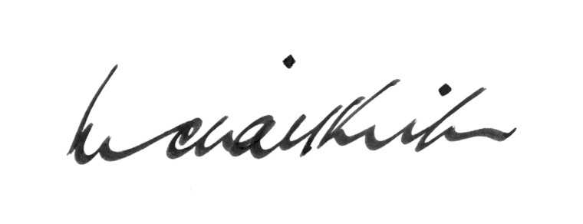

MICHAEL KIRBY
6 June 2007

UNAIDS
CRIMINALISATION OF HIV
PRELIMINARY VIEWS OF MICHAEL KIRBY
(Australia)

