THE AUSTRALIAN CLUB, SYDNEY
REUNION*
Michael Kirby**

FORTY-FIVE YEARS ON

Forty-five years after our graduation with the degree of Bachelor of Laws from the University of Sydney, we gather in this beautiful club to remember those far-off days; to recall our teachers; to recollect our fellow students no longer with us; and to reflect on the things that we still share in common.

Our Graduation Day fell on Tuesday 10 April 1962. Our degrees were conferred by the Chancellor, Sir Charles Bickerton Blackburn who seemed so ancient but was not then so much older than we ourselves are now. We last gathered ten years ago. With depleting numbers, it might be prudent for us to consider reducing the length of the intervals, to say five years. That could make time's whirligig seem to pass more slowly.

Like Chief Justice Murray Gleeson, I thank Charles Curran, one of our number on that graduation day, for organising our reunion. He is far from retired; but he and his excellent secretary chased us up and brought us together. I wrote to him last year suggesting that it was timely, before the Chief Justice and I reached our constitutional quietus, to arrange the reunion whilst we were still young. Boldly, I offered our respective chambers for pre-dinner drinks.

SENTIMENTAL WALK

My contribution has been to lead the assembled graduates of 1962 on a sentimental walk from Phillip Street Sydney to this Club. On the steps of the Joint Law Courts Building, I pointed to where the Queen's Club had once stood, with its elegant white turrets; the newsagency where weekly I purchased my copy of The Listener from the BBC for a mere shilling; Reynaud's Restaurant where Dr H V Evatt took his dinner; and the old hotel that stood on the opposite corner of Phillip and King Streets. Because of my Protestant upbringing, never once did I see the inside of that hostelry.

Next to that hotel, as we remember, was the Phillip Street Theatre where we heard many a lecture. There we sat in the seats occupied on the preceding evening by the rollicking audiences that cheered on Gordon Chater and Barry Humphreys, the latter in his earliest forays upon the world beyond Monee Ponds. Mr Vernon Treatt QC snatched an hour from Parliament to teach us criminal law - there throwing his hat on a chair before launching into a reading of well-thumbed the law school notes.

On our Heritage Walk we passed by the old University Chambers, whose upper floors contained the lecture halls in which we took the majority of our University instruction in law. Sometimes we cast an envious eye across the street to the old Denman Chambers or the new Wentworth Chamber. We could see the busy barristers at work and the life that awaited many of us. On the ground floor of university Chambers Dr Frank Louat QC and Joe Starke had their chambers. Half way up the building, Julius Stone sat in his eerie, as if in intellectual exile. Ron, the lift driver, carried us in the elevators of the adjoining university building that fronted Elizabeth Street.

The overheated library was somewhere there, as was Mrs Gaunson in charge of law school notes. So valuable were these that Mrs Gaunson had her terrier dog Sally always by her side to protect the notes from marauding law students. One Law Lord declared to an Australian Legal Convention in our youth that it normally took lawyers twenty years or so to graduate from their law school notes into new thought about legal doctrine. You can take it from me that, viewed from where I sit, more decades have to be added to this diagnosis. Indeed, many lawyers, and even a few judges, never truly move from the law as it was taught to them in their law school days. In so far as they learn anything new, they generally denounce it and sincerely doubt its truth.

On and on we walked on our pilgrimage. We passed the "new" Leagues Club and the old Federation House where we took lectures in Roman law from Mr Iliffe and later in bankruptcy law. We walked past the shop where the Law Book Company once displayed its wares and where Mr Kelly, always sporting a bow tie and neat moustache, talked me into acquiring my first set of the Australian Law Journal. In 1957 it had reached Volume 31. A month ago, I joined in the celebration of the eightieth year and volume of the Journal, still going strong.

We continued past the place where Radio Station 2GB once stood famous for Jack Davey. Opposite was the small, unmemorable building that then contained all there was of the federal courts - the Federal Bankruptcy Court and the Commonwealth Court of Conciliation and Arbitration, both no more. Our lives, in those days, centred on Phillip Street. Before Chifley Square was created, we could look down the street to Sydney Harbour, glistening in the distance.

I want to thank our colleague David Ross for keeping a record of the fellow students who graduated with us but who have since died. I thank him for reminding us of them. I am grateful to our colleague Bill Henningham for his part in organising this event and for his introduction of me.

SYDNEY LAW SCHOOL TODAY

Like the Chief Justice, I pay a special tribute to Professor Ron McCallum, the present Dean of the Faculty of Law. He has by now lived down his Melbourne past. He has won the affection and respect of Sydney law school graduates. He has taken the lead in planning the long delayed moves of the Faculty to the main University campus. That change was long heralded. It divided the Law School and the students in our days. But now, as the building progresses, there is a common anticipation of great things in store. Especially because this is the eve of the day on which the Dean received from the Governor his insignia as an Officer of the Order of Australia, we, the graduates of 1962, are grateful that he has chosen to spend the evening with us. We are what becomes of his young, vibrant, optimistic students. In thanking him, we express thanks to our teachers who are still very much alive in our memories.

I know of the great achievements of the young students of the contemporary law faculty of the University of Sydney. Yesterday I invited a group of them in my Sydney Chambers to celebrate their success as the Jessup Moot Team of 2007. The Sydney team, for the second time, won the world-wide competition. It is the most intensive global contest amongst law students anywhere. It attracts the best and the brightest from law schools on every continent. In the final, the Sydney team defeated the team from King's College School of Law in London. It did so in Washington before a Bench presided over by a judge of the International Court of Justice. The winning team was Lucas Bastin, Odette Murray, Fiona Roughley, Natasha Simonsen and Zelie Wood. Lucas Bastin, who is an associate to one of our number, Justice Brian Tamberlin of the Federal Court of Australia, was also named the best oralist of the mooters in the 2007 competition. I pay tribute to Dr Helen Irving of the faculty and to a graduate, Justin Hogan-Doran, barrister of Sydney, for the success of the team. They brought the laurels back to our law school. We, the graduates of yore, are proud of their achievement.

I asked the winning team for the secret of their success. They thought about it and then said that they believed it was a willingness on the part of individual members ultimately to sink their own egos and to work closely together for the common cause. They cooperated as a team. They shared the burdens. They thought of each other and supported each other.

As I heard this explanation of the winning Jessup mooter's formula, I remembered a talk given a decade ago by the Hon Tom Uren AO, a past federal Minister and one-time prisoner in the Changi War Prison in Singapore. Tom Uren declared that the reason why so many Australian soldiers survived the ordeal of Changi, when their British, Dutch, French and other counterparts perished, was that they shared everything amongst each other. It did not matter who was an officer and who other ranks. Sharing was the feature that got them through.

I hope that in Australia, despite the modern tendency towards economic rationalism and selfishness, that we will keep alight this special feature of our country. In a sense, the reason why we, a group whose lives has taken us on many different courses, come together is because we shared an intense experience in our youth. We have not forgotten that experience. Despite the passage of time, we too are still bonded by it and by the foundations that it provided for the lives of all of us.

In our graduating class there were few women: Ruth Jones, Jane Mathews, Lillian Bodor, Louise Ferian, Jill Hamer and Diana Henderson - six in a class of ninety two. Now the majority of the students of the Faculty of Law at the Sydney University are women. Women dominate the honours and prize lists. Most of the members of the winning Jessup Moot team, as I have said, were women. The interesting question is whether a 'feminisation' of law will change the values and approaches of our discipline to solving legal problems. It must sometimes have been difficult to have been a woman in the law class in our day. They were the forerunners. They broke the mould.

THE FACULTY

We are united in our memories of the faculty of the law school of those days. Through the vast resources of the High Court of Australia, I have secured a copy of the calendar of the University of Sydney for the year 1962. The Chancellor, as I have said, was Sir Charles Bickerton Blackburn, approaching the last years of his service. Professor Stephen Roberts, soon to be knighted, was Vice-Chancellor. Harold Wyndham, the Right Hon H V Evatt and our own Dean, Professor Kenneth Shatwell, were Fellows of the Senate.

Professor Shatwell was famous for his early writings on the doctrine of consideration and mistake in contract law. One had a feeling that he was so exhausted by that effort that this intellectual life did not thereafter progress as much as he would have wished. Julius Stone, by way of contrast, was a dynamo of the intellect and productivity. As Challis Professor of International Law and Jurisprudence, he lifted our thoughts from mundane aspects of law. He opened our minds, as a great law teacher should.

Professor David Benjafield taught us Constitutional Law I - the foundations of British constitutional law. It was he who presented us on our Graduation. A man of sweet disposition, he was one of the early illustrations for us of the principle that disabilities are not afflictions for the gifted and determined. In his wheelchair, he would come to the Law Ball. Accompanied by his wife, he would join us with a happy spirit.

William Loutit Morison sometimes appeared a cold man. But he was brilliant in his exposition and analysis of the law of torts. I sometimes wonder what he would make of its current messy manifestations.

Ross Parsons made revenue law and company law a subject of special emphasis at the Sydney Law School. He rescued these areas of statutory concern. He taught them with the enthusiasm that their social and economic importance deserved.

Amongst the senior lecturers were many whom we came to know well. J A Iliffe, who taught us Roman Law and insisted in doing so in a simple black robe, as if to signify his English origins and his disdain for the barbaric informality of his new antipodean homeland. His shoes often bore witness to the chicken farm which he ran somewhere on the central coast.

The brilliant and cerebral Pat Lane taught us federal constitutional law. The little book he wrote on the subject is out of date now. But I suggest that no other text captures in an equivalent way the key features of our Constitution. He had a remarkable mind. Ilmar Tammelo worked with Julius Stone in teaching us jurisprudence and public international law. He was also a man of gentle disposition. For some reason which I could not fathom, he chose me to examine a huge pile of speeches, translated by him from the original Russian. The speeches had been given by the leaders of the Soviet Union on the Marxist theory of the doctrine of the withering away of the State. It became the basis of my LLM thesis. Little did either of us anticipate that the mighty Soviet Union of our law school days would indeed wither away, but not in the manner that those speeches ever contemplated.

Professor D C Thomson taught industrial law. Gordon Hawkins introduced us to criminology. Amongst the other lecturers was the redoubtable Dr C H Currey who taught us legal history in first year. Also there were R M Hope and F C Hutley, later to be my colleagues in the Court of Appeal. A F Mason was Challis Lecturer in Equity, although our class was actually taught by Dicky Bentham. Denys Needham, Barry O'Keefe, Arthur Rath, David Selby all later became judges of the Supreme Court. They taught or tutored us in between their already busy lives as barristers.

In the list of the faculty, Ted St John QC is described as the Challis Lecturer in Legal Interpretation. I do not recall a special course in legal interpretation in my training at the law school. Perhaps this is because Murray Gleeson, with whom I shared the taking of lecture notes, suppressed that part of my legal preparation. When I was at the Harvard Law School in December 2006 I was told of the legal revolution being accomplished there. That great school, which first introduced the case book method, and taught law through the words of judges, has now abandoned that system. Legal interpretation is a compulsory course taught in first year to reflect the dominance today of statute law.

The part-time teaching fellows in 1962 included Roddy Meagher, Philip Powell, Andrew Rogers and Theo Simos, all of whom went on to become Supreme Court judges. The road to the bench often led through those ramshackled, airless tutorial rooms in the old Law School building. The judiciary and the wider profession still require people of intellectual excellence and discipline to renew their numbers.

PASSING TIME

Since we last met, two of our group have died. I had special links with each of them.

Phillip King I knew from Arts days. Because of the alphabet, we sat together under the vaulted ceiling of the Great Hall, sweating over the examination questions. He went on to play a leading role in the firm that is now Allens Arthur Robinson. It was he who organised our last reunion. I miss him.

I also miss Graham Hill, who was the University medallist in our graduating class. I first met him on a February day in 1949 when we both arrived at the Summer Hill Opportunity School in Sydney. He was brilliant then and he displayed his ability at Fort Street High School and as an undergraduate. He was to play a notable part in the teaching of revenue law. He was a disciple of Ross Parsons. At his death, he was the longest serving lecturer in the Sydney University Law School.

In March 2007, I was invited by the Australian Taxation Institute to inaugurate a memorial lecture in Graham Hill's honour at the Institute's conference in Hobart. I was greatly touched by the obvious affection and respect that the 600 participants at that conference felt for Graham Hill, our old colleague. They listened in silence to my tribute to him. Later, many expressed their personal debt to his leadership and instruction.

So when we look back, what do we remember? Is it the lecture halls and the cramming for exams? Is it perhaps the Catalina Restaurant at street level in the old Law School building fronting Elizabeth Street? Its advertisement in a Blackacre of those days boasted, astonishingly, that its atmosphere was charming and gay. I suggest that it is something more than these things. We remember each other as young people, with bright minds open to the instruction of talented teachers. We remember some of those teachers more than others. In my own case, it is the experience of learning from, and working with, Julius Stone that I remember most vividly. It was "Big Julie", as we irreverently called him, who taught us lessons that ran counter to the professional orthodoxy of the time. That law contained many categories of indeterminate reference. That law inescapably reflects and expresses values. That judges have choices and reach their dispositions influenced by such choices. That the choices should be transparent and principled. These were great lessons for law and for life.

As we have become older, we have accumulated a little wisdom. We are wise enough to know that office and professional success may be important. But that the greatest success in life lies in personal things - in children and grandchildren if we have them. In close relationships and love.

I am grateful to Bill Henningham, in his introduction of me, for mentioning my efforts, including for sexual minorities: gays, lesbians, bisexuals and so on. When we were at law school, in criminal law, we were taught by Vernon Treatt about the so-called "unnatural offences". When he reached that part of the course, with Treatt describing those laws at the podium in the old Phillip Street theatre, you can imagine perhaps how I felt. It was an oppression. I was a victim of it.

Of the things I have done in my life, the one of which I am most proud is to have formed a relationship with my partner, Johan. It has now lasted thirty-eight years. It began in 1969, in the same decade in which we graduated. It is still going strong. The discrimination and injustice have not been entirely eradicated, including from the law. But we have made progress. In part, it is because people stood up and objected to irrational and unjust laws.

So when, Dean McCallum, you present this year's law graduates to the Chancellor this coming Friday morning, please give them greetings from their predecessors, the graduating class of 1962. Tell them that the survivors gathered in Sydney this week to remember their own graduation; the company of t hose who were there; their teachers and the University. Tell them that law can be a noble profession, with a commitment to order intertwined with justice. Give them encouragement from all of us as they embark on their lives: full of hope and optimism just as we did. In forty-five years they too will gather in reunion and remember and reflect on things that pass and things that endure.
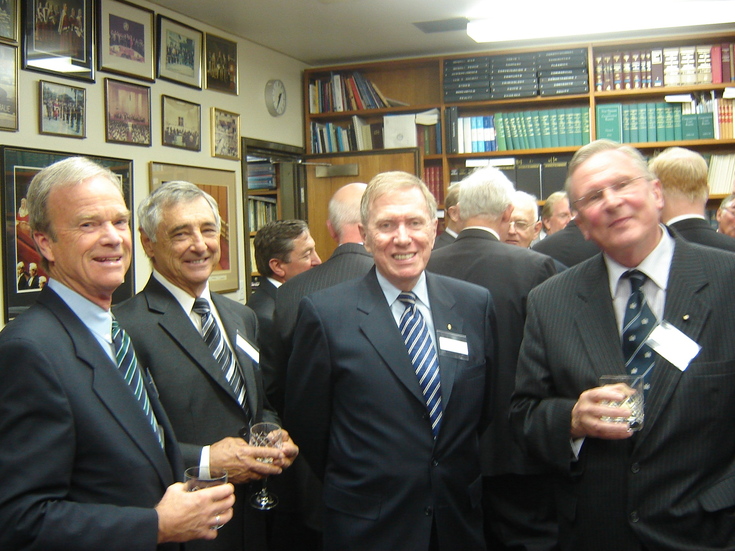
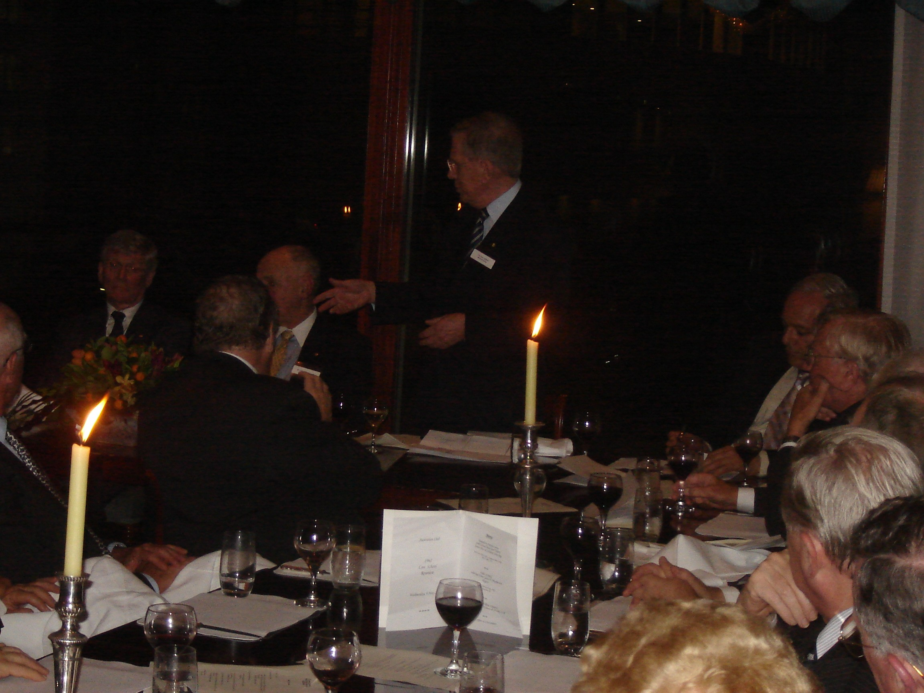
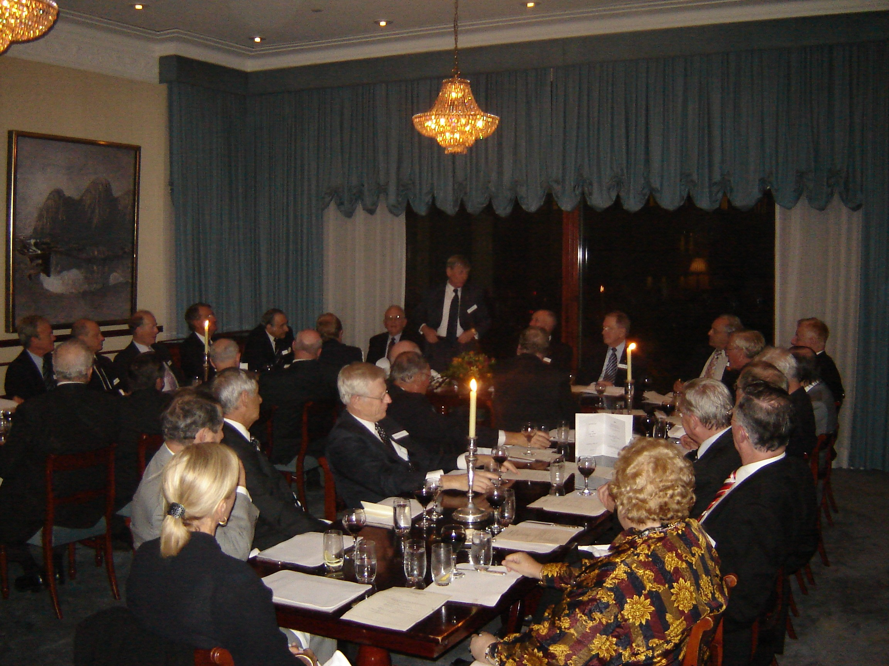

THE AUSTRALIAN CLUB, SYDNEY
REUNION
Michael Kirby

* On which was based remarks made du ring the Reunion of the Graduating Class of the Faculty of Law, the University of Sydney, Australian Club, Sydney, Wednesday 9 May 2007.
* * Justice of the High Court of Australia.

