SIR JOHN BARRY
FOREWORD
The Hon Justice Michael Kirby AC CMG*

In his retirement speech as Chief Justice of Australia, Sir Owen Dixon lamented the failure of the selection process to deliver onto the High Court lawyers whom he had known of great ability. Strangely, for such a prudent man, he mentioned a couple whose non-appointments were "two tragedies in the life of the High Court which did not depend on a particular event or a particular thing, but which just went on". One was Sir Leo Cussen of the Supreme Court of Victoria. The other was Sir Frederick Jordan, past Chief Justice of New South Wales.

Omitted from Dixon's short list, perhaps unsurprisingly, was the name of Sir John Barry. Yet as we know, Barry came very close to appointment in 1946. He was well regarded within the Labor Government of Ben Chifley. H V Evatt, who had sat on the High Court in the 1930s, before returning for a time to politics, admired Jack Barry and proposed his name to the federal Cabinet. Ben Chifley, cautious as ever, did not favour the appointment. When rumours that Barry was under consideration began to circulate in April 1946, a leading member of the Country Party, H L Anthony, demurred: "I am not challenging Mr Barry's probity, but does anyone suggest he would not be prejudiced if legislation by this government came before him?".

In the result, Evatt switched sides to support Sir William Webb, a "safe appointment" also favoured by Chifley. At the time, Webb was Chief Justice of Queensland. Many in the Cabinet, including John Dedman, Don Cameron, Arthur Calwell and Eddie Ward voted for Barry. By report, the debate was fierce and the vote close. But in the end, Webb was appointed. His contribution as a Justice was sound; but not memorable.

Professor Geoffrey Sawer remarked that the High Court would have gained much from the presence of Barry, a "gadfly … who would have set a brilliant non-conformist mind against the powerful but deeply conservative thought of Sir Owen Dixon". It is little wonder then that Dixon did not mention Barry in his farewells. Like many jurists of his philosophy, Dixon would have regarded Barry as someone who was not his kind of man - a person on a different wave length, with wide interests and novel insights. In fact, Dixon would have found Barry's world view "queer": the adjective he used to describe Sir Frederick Jordan's later opinions about the Constitution.

I have a strong empathy with Sir John Barry, whose life is now recorded and explained in this splendid book. He died shortly before my first judicial appointment. Because I came from the New South Wales Bar, I never met him as a judge nor in the comradely circles of the local Bench and Bar. However, I had studied his judicial opinions, his writings on criminology and his posthumously published lectures The Courts and Criminal Punishments. These were commended to me soon after I was appointed to chair the Australian Law Reform Commission. When one of the first projects of that Commission was addressed to the reform of federal sentencing law, it was natural that I should immerse myself in Barry's life and work as a judge, as a scholar and as an expert in the foundling science of criminology.

Barry was one of the earliest of Australian judges to see, and express, an awareness of the social context within which the law operates. He had, as Sir Zelman Cowen wrote of him soon after Barry died, "a taste for legal learning and more besides". He was no narrow jurist. For him, law was not a club for the like minded. His perspective was the more remarkable because he had not had the advantage of instruction in jurisprudence by Julius Stone but was someone educated in the rather more conservative rhetorical tradition of Melbourne of that time.

Barry was innovative and fresh in his outlook towards law. He was concerned about the way law operates in practice, and not just in the books. It was this that took him to an interest in criminology. Indeed, it was his writings on that subject, and his later service as chairman of the Victorian Parole Board, that helped make criminology a respectable object of study for the Australian judiciary and legal profession.

In his interests and outlook, Barry did not confine himself to Australia, as many of his generation did. He led delegations to United Nations Congresses on the prevention of crime and treatment of offenders, held in Geneva and London. He was thus an early convert to the need for lawyers to think globally, beyond the British Empire and even beyond the common law and Anglophone world.

He was assiduous in the discharge of his judicial duties. But he wrote for pleasure on the subjects of science and history, including his famous book on Alexander Maconochie (1958) which earned him the Doctor of Laws degree of Melbourne University. At one international conference delegates took to calling him "Sir John Maconochie", which his colleague and disciple, Noval Morris, says occasioned him "mingled pleasure and annoyance".

Barry surprised some admirers by accepting the knighthood that then went with his senior judicial status in Victoria. However, like most of us, he was not a stereotype but a complex mixture of the elements. Sir Zelman Cowen describes his "taste for panoply and ceremony" and "personal conservatism that took pleasure in established forms of community recognition". Yet he was a life-long opponent of the death penalty. And no one could have been drawn to such an interest in criminology without some degree of human empathy for those who are on the receiving end of judicial punishments.

It is not unusual, amongst lawyers, to see capable, skilled professionals with a few outside interests and a love of the forms and ceremonies in which the law delights. What was unusual, and what lifts Barry well above the ordinary, is to find a capable professional who, in middle years, kept the mind open for novel, unorthodox and challenging concepts. The type of concepts that many disdain or dismiss with condescension. Such liveliness of mind is specially precious because the daily grind of legal and judicial work has a tendency to stamp it out. Little wonder that J V Barry was a controversial nominee for the High Court of Australia. Little wonder that he was not appointed.

Despite this, his career saw many achievements, as recounted in these pages. We are fortunate that it has now been recorded for us to consider and reflect upon for its ongoing lessons for our Commonwealth. In his lifetime, Barry realised the importance of criminology, family law reform and of questioning assumptions about the law, its doctrines and practices. Perhaps some readers of his life's story will be encouraged, in the future, to tread a similar path. It is the genius of our system of law that it tries to resolve the warring tendencies that Barry's life manifested. To preserve the order and the comfortable predictability of things long settled. And, at the same time, to question such things. To stimulate the questioning from knowledge gleaned from outside the circle. And to change what can be altered when the questioning shows that change is needed.

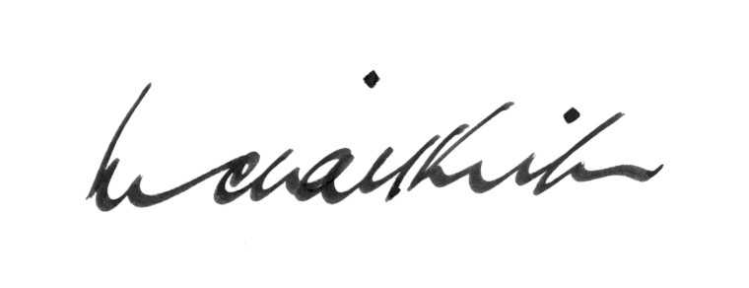

High Court of Australia Michael Kirby
23 April 2007

SIR JOHN BARRY
FOREWORD

The Hon Justice Michael Kirby AC CMG

* Justice of the High Court of Australia.
Speech by the Right Hon Sir Owen Dixon on his retirement as Chief Justice of the High Court of Australia (1964) 110 CLR v at x.
T Simpson, "Appointments That Might Have Been" in T Blackshield and Ors, Oxford Companion to the High Court of Australia, OUP, 2001, 23 at 25.
Ibid, 25.
(1964) 110 CLR v at xi.
Z Cowen, "J V Barry: A Memoir" in N Morris and M Pearlman (eds) Law and Crime (1972), 222 at 228.
N Morris, "Corrections and the Community" in N Morris and M Pearlman (eds), Law and Crime (1972), 133.
Cowen, above, 235.
M D Kirby, "John Barry on Sentencing: A Contemporary Appraisal" (1979) 12 Aust and NZ Journal of Criminology 195 at 199.
G Sawer, in N Morris and M Pearlman, above, 14.

