ABOVEBOARD PUBLIC ACCOUNTABILITY FORUM
FOREWORD

I love administrative law. Why? Because it is about the control of power and improvement of the governance of our society. It also mixes the mind games of high legal theory with the practical outcomes of promoting more accountability and transparency in decision-making.

I also like administrative law because I know quite a lot about it. From 1976, it was my privilege to participate in the Administrative Review Council. I was there when the new federal administrative law was created. The Administrative Appeals Tribunal Act 1975 (Cth), the Ombudsman Act 1976 (Cth), the Administrative Decisions (Judicial Review) Act 1977 (Cth), the Freedom of Information Act 1982 (Cth), the Privacy Act 1988 (Cth) and many more laws and policies were adopted to improve federal administration in Australia. It was an exciting time. Much was achieved. I learned a lot about the theory and practice of this corner of the law. When I get a case concerned with administrative law, my heart leaps up.

All branches of government at every level should be accountable to the people. In the case of the executive government, the provisions of the Constitution, s 75(v) help to make this so. I encourage the participants who are taking part in this Forum. Especially the young participants for they will have the responsibility of continuing the advance of accountability so that democracy in Australia is a reality and not merely an empty boast.
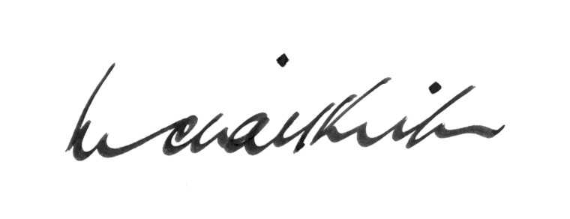

Michael Kirby
Justice of the High Court of Australia

ABOVEBOARD PUBLIC ACCOUNTABILITY FORUM
FOREWORD

