JOURNAL OF AUSTRALIAN TAXATION
THE LATE JUSTICE GRAHAM HILL
Michael Kirby*

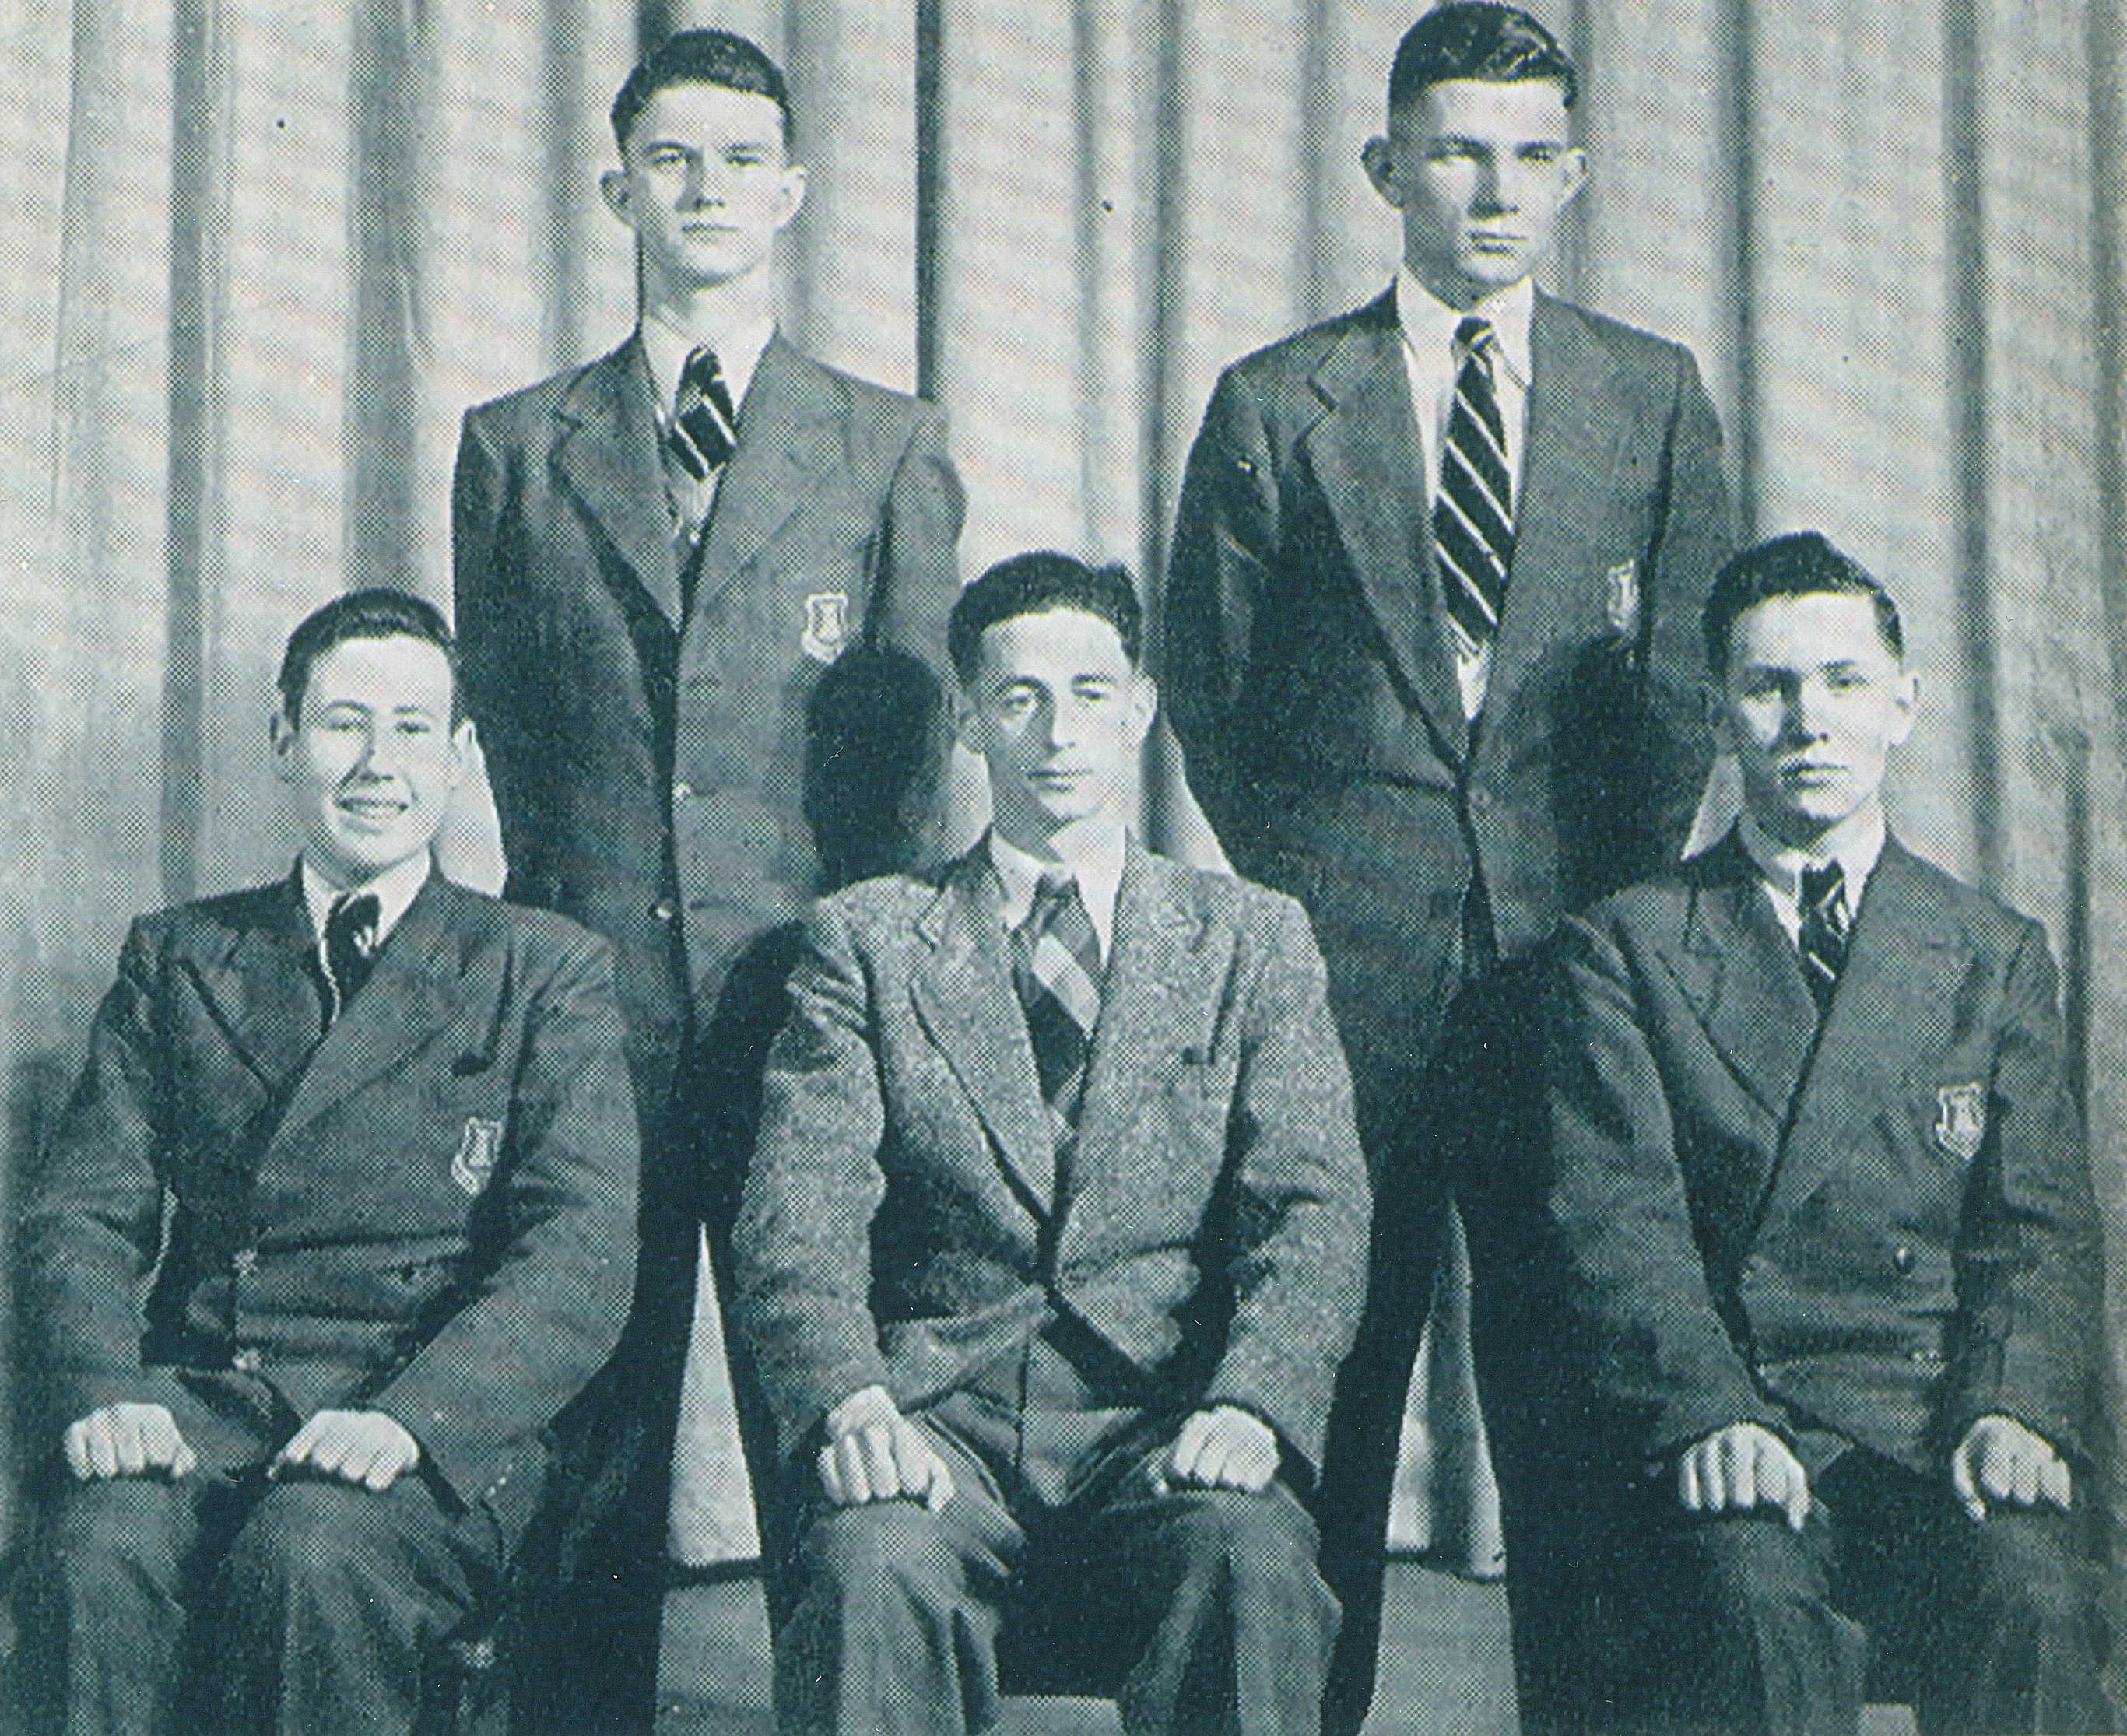

Graham Hill and Michael Kirby are seated in the front row on the left and
right respectively (Fort Street Boys' High School, Sydney 1954)

Justice Graham Hill died in Sydney on 24 August 2005. I knew him longer than virtually any other living person. I pay my tribute to his life and work.

Graham Hill and I were products of the public education system of New South Wales. Specifically, we were students in the selective schools into which are admitted children of parents of modest means who prove talented in their primary school studies and who, in our day, did well in the intelligence tests administered to single out 'gifted' pupils.

I first met Graham Hill on the day, in late January 1949, when we both arrived at the Opportunity "C" class at Summer Hill, a western suburb of Sydney. We were entering fifth class in the primary school. He was already ten years old, having been born on 1 November 1938. My tenth birthday lay ahead, in March of that year. He had come from the public school in Haberfield, a nearby suburb; I from North Strathfield Public School, five miles away. At the time, he was a chubby child. Rather cruelly, some of the students in our class (who might have been intelligent but were not always insightful) called him "fatty". I befriended him. Indeed, we became very close friends. From the start, he proved himself a high achiever. Slightly envious of his consistent grades, I attributed his immediate success to the fact that his mother, Essie Tinsley Hill, was a schoolteacher who gave Graham, her only child, special tutoring at night. Whether she did or not I never knew. But I suspected that this was his secret weapon.

At Summer Hill, we had fine teachers, Mr Gorringe in fifth class and Mr Tennant in sixth. As chance would have it, the latter was injured in a motor car accident in 1950. As a result, the Principal of the Summer Hill Primary School, Mr Gibbons, took over our class. He was a veteran of the First World War (as were many teachers at that time). He wielded the cane as a regular instrument of discipline from which his precocious charges in the opportunity class were not spared. I cannot remember Graham Hill ever receiving the cane. It seems highly doubtful. But I did so once: literally for blotting my copybook with departmental ink. Our instruction at Summer Hill, in an all male class, was strong on Gilbert and Sullivan, concerts and creative expression. It was not so strong in the tedious realities of mathematics, English and history.

Both Graham Hill and I took part in the school concert in December 1950 - it was a performance of The Mikado. We also gained our parents' permission to attend theatres to see live performances of G & S with Ivan Menzies in the lead role at The Empire, a theatre that then flourished at Railway Square. At one stage, I was invited to join Graham and his parents in their annual holiday at Patonga. A holiday away from home was a luxury my parents could not afford.

Graham Hill's father, Cyril Vere Hill, was a bank employee. He was somewhat portly, indeed overweight. Whereas he was a gentle, retiring man, Mrs Hill was strong willed, assertive and decisive. I remember being a little afraid of her; but Graham loved her dearly and she returned his love.

In December 1949 we witnessed the election of the new federal government, led by Mr R G Menzies. We were instructed in current affairs by our teachers. On the radio, with a large brown speaker positioned high above the class, Mr H D Black gave talks about the world we lived in. The demise of the Labor Government, led by Mr Chifley, marked a big turning point in Australian life. Although we were young, we knew it. Mr Menzies had promised to "put value back in the pound". The Coalition Parties were to remain in government until 1972.

In December 1950 we gathered under the big fig tree that still stands in front of the Summer Hill Public School. There, Mr Gibbons, caneless for the occasion, read out the high schools to which we had been assigned for the following year. Graham Hill and I were assigned to Fort Street Boys' High School. It was to be a continuation of our selective education. It was a school famous for its professionals, and especially its lawyers and judges.

At Fort Street, Graham Hill's academic strengths quickly shone. In second year, we each elected to study German. This took us into a small class with a remarkable teacher, Mr Ronald Horan. He was to become the 'Mr Chips' of Fort Street educators. He had attended the school himself before service in the Second World War. He was young, enthusiastic and a magnificent teacher. His German class for the Leaving Certificate comprised only six students. It was an exciting place to be. Every one of the students, Graham and myself included, gained maximum passes in the New South Wales Leaving Certificate in 1955. Graham Hill gained First Class Honours in English and Modern History; I in Modern History and Economics.

Although he had regularly out-performed me in academic results at the school, in the Leaving Certificate I pipped him at the post. Like me, he took an active part in debating. In the school magazine, The Fortian for 1954, we both stare from the pages in a photograph of the junior debating team. Graham Hill is also recorded there as giving an Empire Day address in 1954 on "The Commonwealth and This Changing World". I followed him with an address "The Empire and You". We gathered that year in Concord Park, with students in their thousands, to welcome the first visit of The Queen. Both of us took part in drama at Playday. I am ashamed to say that neither of us brought much credit on the school in matters of sport.

Graham Hill's father died whilst he was at high school. Following this, he and his mother moved from their family home in Ramsay Road, Haberfield. This left his paternal grandmother and his aunt (Violet Hill), who lived there, thirsting for news of their grandson. I was invited by them to perform lawnmowing duties in their backyard for five shillings. It was really a pretext by which they hoped to get news of "Donald", as they called him. Graham Hill did not much like his first given name of Donald. However, as it was my middle name, and the name of my father and brother, he was always too discreet to say so.

Our lives separated somewhat during the years at Fort Street High. We were never to recapture the intensity of our friendship in those first years at primary school.

Graham Hill came up to Sydney University in 1956 and, like me, gained the degrees of BA in 1959 and LLB in 1962. He administered revenge in academic prowess when he graduated in 1962 with the University Medal in Law. Ours was a strong year. It included many graduates who have gone on to highly successful careers in law, government and business. They included Murray Gleeson (now Chief Justice of Australia). David Hodgson, the Rhodes Scholar, now a Judge of the NSW Court of Appeal. Kim Jones, later an Australian Ambassador and now Director-General of the Office of National Assessments. Jane Mathews, one of Australia's first female judges. Charles Curran, a leading businessman and many more. Amongst these, Graham Hill stood out for his sharp intelligence, deep legal knowledge and dedicated interest in legal education.

At the Sydney Law School, he was one of those who was quickly identified by Professor Ross Parsons as having the subtlety of mind and mastery of detail that would suit him well to undertake a gruelling life of advising on, and teaching, tax law. From that start, Graham Hill was to expand his lifelong love affair with revenue law. At the time of his death, he was probably the most respected judge and lawyer in Australia on the intricacies of federal tax law and State stamp duties law. In part, this reputation flourished because of the teaching duties he performed at the Sydney Law School for over forty years, his generous readiness to contribute to discussion groups on tax and his willingness to rise to the occasion with after dinner talks at the conferences and annual dinners of revenue experts.

After graduation, Graham Hill proceeded to Harvard University where he gained an LLM degree. By that time, I had become caught up in student affairs so I continued my studies at Sydney University, gaining an LLM and BEc there. Graham Hill's postgraduate degree was of stellar quality, lending some support for Gareth Evans' unkind remark, that unlike himself (and for that matter Graham Hill), I had concentrated on academic quantity rather than quality.

On his return to Sydney from Harvard, Graham Hill became a partner at Parish Patience and McIntyre, solicitors (1965-69). This was followed by a time as partner at Dawson Waldron, solicitors (1970-76). During the period that he was at Parish Patience, I was a partner at Hickson, Lakeman and Holcombe, also a Sydney firm of solicitors. We would see each other around the legal traps. He would tell me that he was serving as a part-time lecturer at the University of Sydney. Occasionally we would meet at school reunions. Eventually, in 1976, he took the plunge that I had taken nine years earlier. He was admitted to the New South Wales Bar. By that stage I had been appointed to the Arbitration Commission (in1974) and seconded (in 1975) to chair the Australian Law Reform Commission.

Our lives came together again when, in 1984, I was appointed President of the New South Wales Court of Appeal. It was in that year that Graham Hill, after only six years at the Junior Bar in Sydney, was appointed Queen's Counsel. He already dominated revenue work. He argued several cases before me in the Court of Appeal. One of the most interesting was John Fairfax and Sons Ltd v Deputy Commissioner of Taxation. The question was whether colourful and glossy "flyers" that were inserted in Sunday newspapers published by Fairfax were, for sales tax purposes, part of the "newspaper" (and thus exempt from sales tax) or not.

At first instance, Justice Enderby had concluded that the flyers were not part of the newspaper. Graham Hill QC mounted a compelling argument for Fairfax et al that the content and definition of "newspapers" was something that was ever-changing. He persuaded all of us in the Court of Appeal (Justice Gordon Samuels agreed with me and Justice Dennis Mahoney substantially agreed) that his arguments were correct. I recall that his argument was extremely clever. He would have known of my susceptibility to submissions based on new technology and changing social circumstances. But he had to press those points without losing Justice Mahoney who did not think that the point of statutory construction was to be determined "according to matters of this kind". The deft way in which he wove his arguments, gathering in all of the judges of the Court of Appeal, without losing any, earned my admiration at the time. He was a fine advocate. As with his teaching, he had gifts of simplifying extremely complex revenue legislation. Not all of his problems were as straight-forward as the "newspaper" case.

Later, my partner, Johan van Vloten, was to curse Graham Hill's success in the newspaper litigation. For a time Johan was a newsagent, condemned in the early hours of winter to wrap and deliver newspapers. They were newly made much heavier by the flyers which became more numerous and bulkier as their tax-free status added to their attractions. The next time you purchase a newspaper and a collection of flyers falls out to general consternation, you will know who to blame.

In 1989, whilst I was still serving in the Court of Appeal, Graham Hill was appointed a judge of the Federal Court of Australia. This was his natural home, for that court had already become the main jurisdiction in which tax appeals were fought out in federal revenue cases. Indeed, Chief Justice Mason was to declare, possibly because of the distinction quickly earned in the analysis of tax law by Graham Hill and other judges of that court, that tax appeals were normally to cease in the Federal Court. The glory days when the High Court of Australia, in its original and appellate jurisdiction, heard and decided large numbers of tax cases were over. Now, appeals in such cases are comparatively few. Yet there are happy moments. Recently, in one day, Justice Callinan and I gave special leave to two such appeals: Forsyth v Deputy Commissioner of Taxation and Avon Products Pty Limited v Commissioner of Taxation.

In 1996, when I was appointed to the High Court, Graham Hill, with our mutual school friend Arnold Milton, a Sydney chartered accountant, organised a luncheon to celebrate the appointment. It was a happy event. I felt a revival of the feelings we had shared so many years earlier at primary school, when we were close friends. It was clear that the school experience had not been as happy for Graham Hill as it had been for me and for most of "the year of 1955". On one occasion, he came to a school reunion to give the after dinner speech. His school friends were not ready for his critical remarks about the school, its elitist traditions and its adulation of "success". As I look back on his talk, I can see that he may have been revealing some of the pain he had felt at school for not making it into the "magic circle" of the prefects and the most popular boys. We would have done well to listen more closely to his remarks, rather than to resent them. Graham Hill was nothing if not insightful and honest. Rare is the speaker at a school reunion who tells the audience home truths as he sees them. Graham had no time for humbug. He was not sentimental. Nor was he given to nostalgia.

The years passed and we each performed our respective judicial functions. Occasionally, during weeks when I was there, I would see him approaching the elevators in the Sydney Law Courts. Sometimes he would come onto the level of the Law Courts building where the Sydney chambers of the High Court Justices are found. We would engage in passing, friendly comments. But it was never an extended exchange. He was on his way to court.

Soon after my appointment to the High Court, the media latched on to the disclosure in Who's Who of my long-time relationship with my partner, Johan. Graham Hill went out of his way to express his support. So he did, when, in 2002, I was attacked in the Australian Senate - in words that were later withdrawn. On both of these occasions, Graham Hill revealed a side to his personality that I had not known, or had forgotten. He had strong feelings about human rights and human dignity. He was outraged by unfair discrimination. Normally, in his work as a judge, he kept these feelings under close wraps. But they were there. And they were strong. They came to the fore in his remarks when Sydney University awarded him the Honorary Degree of Doctor of Laws. He made a number of powerful observations about migration law and refugees which his duties in the Federal Court obliged him to administer day by day. This speech, which gained a lot of attention in the public media, showed the deep currents that ran within Graham Hill and the strong commitment he had to fundamental human rights, justice and human decency.

A few months before his death, I participated in the High Court decision in Commissioner of Taxation v Stone. In my reasons, I disclosed, I hope, the deep respect I felt for the accuracy and care which Graham Hill brought to bear in his decisions on tax law. I later heard of his concern about appellate reversals of some of his rulings - which I knew from my own life is always the fate of judges who operate below an ultimate court of appeal. I was surprised at these reports. They conflicted with the image that I held of a lawyer and a judge, at the height of his powers, who was rightly full of confidence in his ability to decide very hard legal questions, and specifically revenue questions, with the greatest of accuracy and efficiency.

All of this goes to show that we, who were his companions on the legal journey, and even those who were his professional colleagues and friends, did not perhaps know the inner workings of the mind and heart of this brilliant, reserved man. He was one of the finest lawyers and most successful judges of his generation. From his schoolboy days to the very end, his intellectual gifts shone forth. His deepest feelings he kept to himself and perhaps the very few closest to him.

How does one explain this? Perhaps it was the reserve that is common to the Scots, who were his forebears. Perhaps it can be traced to divisions in his family in his childhood, symbolised by the different names given to him by the different sides of the family. Perhaps it was just (as a former staff member suggested to me) that he was a consummate professional actor who was happy to reveal his lawyerly skills but normally kept his personal thoughts and feelings to himself. If the true explanation is the last, he learned well the talents of treading the boards at Playday at Fort Street High School, fifty years earlier.

The motto of the school is Faber Est Quisque Suae Fortunae. Loosely translated, this is: "All of us make our own success". By the standards of the world, and what was expected of him, Graham Hill fulfilled the aspirations of that motto handsomely, however sceptical he later became about its message. For him, the success he pursued was not wealth. It was a repayment to the community that a person with special gifts can make, through education, community service and devotion to his chosen skill. The year just past has seen the loss of many fine judges of the Federal Court of Australia, most of them professional colleagues and friends. The loss that pains me most is that of my old school friend, Graham. I wish I had reached out to him more than I did. Now that he is dead, I can only reflect on his life and speak praise of his name.

Graham Hill left many admirers. This was shown by the unprecedented congregation that packed into St James Church, Sydney, for his Memorial Service. Present was his wife Ute, from whom he was separated, and his children Katrine and Peter, together with grandchildren. Amongst the speeches were those of Chief Justice Michael Black AC of the Federal Court of Australia, Professor Faith Trent AM of Flinders University, South Australia and John O'Brien. We will never again see a judge and legal colleague who so bestrode the world of revenue law as Graham Hill did. I am not alone in this prediction. More important for me, however, is the loss of a friend of school days. Thinking of Graham revives memories of the sunny classrooms in Sydney in the 1940s when the world was so different and our lives beckoned us ahead, full of promise and hope. Now he is gone and I think of him often with gratitude for his life and for our friendship.

JOURNAL OF AUSTRALIAN TAXATION
THE LATE JUSTICE GRAHAM HILL
Michael Kirby

* Justice of the High Court of Australia.
The Fortian, 1954, p 26.
R Richards, "Justice Graham Hill, the End of an Era" (2005) 43 No 9 Law Society Journal (NSW), 45.
(1988) 15 NSWLR 620.
(1988) 15 NSWLR 620 at 634.
His countless decisions in tax law included the highly publicised decisions in the Consolidated Press Cases (1998) 88 FCR 21; (1999) 91 FCR 524 which went to the High Court: (2001) 207 CLR 235 where his reasoning proved decisive.
[2005] HCA Trans 848.
[2005] HCA Trans 847.
E Campbell and M Groves, "Attacks on Judges Under Parliamentary Privilege: A Sorry Australian Episode" [2002] Public Law, 625.
Richards, above n 2 at 45.
D G Hill, "Graduation Address: Justice Hill" (2003) 77 Australian Law Journal 275.
(2005) 79 ALJR 956 at 973-974 [104]-[105]; 215 ALR 61 at 84-85.
Richards, above n 2, 45.

