THE UNIVERSITY OF QUEENSLAND

T C BEIRNE SCHOOL OF LAW

SIR HARRY GIBBS NATIONAL MOOT COMPETITION

MONDAY 10 OCTOBER 2005

TRIBUTE TO THE RIGHT HON SIR HARRY GIBBS GCMG AC KBE

Michael Kirby*
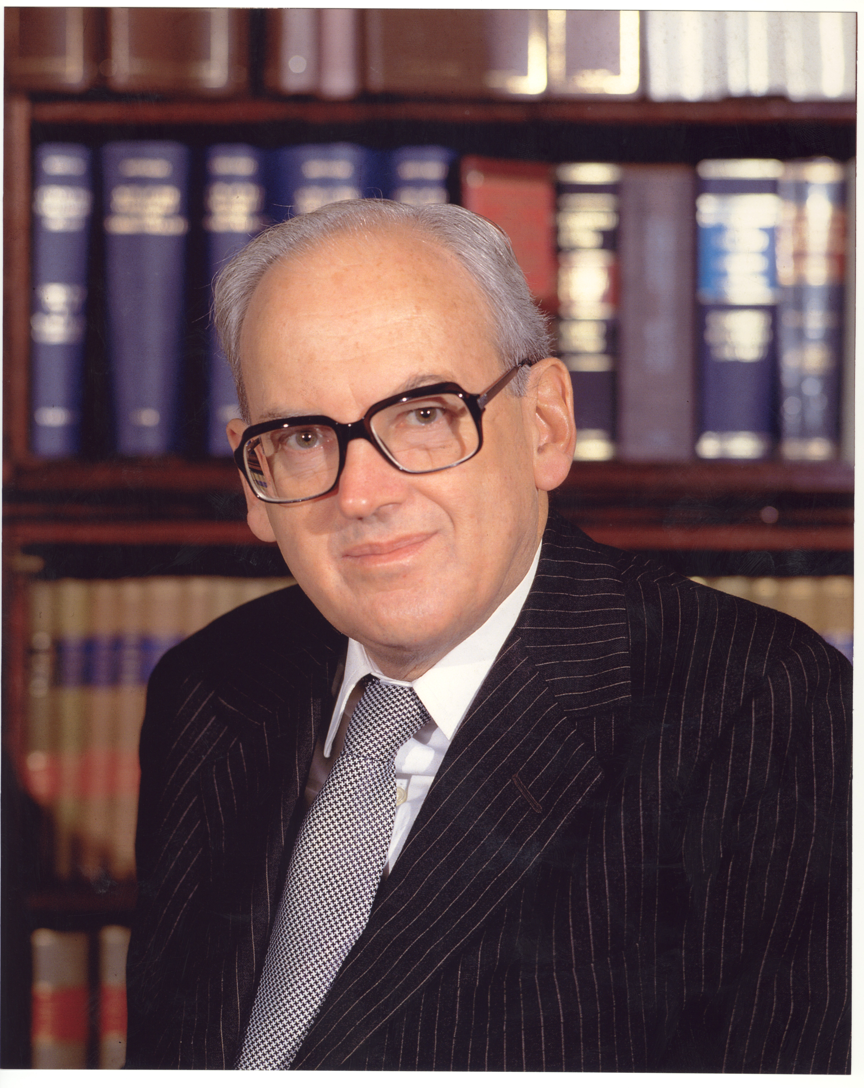

Andrew Sullivan, long-time senior editor of the New Republic and columnist for the Sunday Times in London, has written a beautiful essay on friendship. It was published in his book Love Undetectable (Vintage, 1998). The book concerns Sullivan's discoveries about himself, the world and people around him after everything seemed to fall in when he was diagnosed HIV positive.

His chapter on friendship necessarily touches on the difficulties presented by his condition and the high dependency he felt on personal and medical friends, especially before new pharmaceuticals kicked in to give him a "second chance" to life. However, his essay is focussed more generally. It concerns the beauty of friendship. His thesis is that, in the modern age, friendship has become a much under-rated commodity. At a time when love, sex and exclusive family relations are given so much emphasis, friendship, according to Sullivan, has been under-valued. He quotes Cicero in De Amicitia as saying:

"And this is what we mean by friends: even when they are absent, they are with us; even when they lack some things, they have an abundance of others; even when they are weak, they are strong; and, harder still to say, even when they are dead, they are still alive".

This is how I feel about my friend, Bill Gibbs. In many ways, we were opposites. His judicial and social philosophy was very different from my own. His life's experience was different. He looked at the world through different spectacles. We would often agree to disagree over this or that. But now that he is dead, I think back on the friendship that we shared in various activities where our lives were thrown together.

For a time, we both served in important federal positions - he as a Justice of the High Court of Australia and I, the newly appointed Chairman of the freshly minted Australian Law Reform Commission. Then we worked together in the committee of the Australian Academy of Forensic Sciences, he as President before I too took up that position. Over twenty years we attended together the meetings and ceremonies of the Australian members of the Order of St Michael and St George. He held the top office in that Order as a Knight Grand Cross (GCMG). I was Malcolm Fraser's last appointment to it in 1983 - the last CMG in the Australian list. Then there was the time we worked together in Australians for Constitutional Monarchy to preserve the system of government that everyone else scorned - saying it was doomed to popular rejection.

In most recent years, we would meet and exchange thoughts from the perspective of service on the nation's highest court. We skirted around points of difference but found many of agreement.

Now, in the aftermath of his passing, I think back on the life of this friend. What does it matter that we disagreed, even over things that seemed important, perhaps fundamental? We both knew that we lived together in a society, and in institutions, that afforded many common links. Our friendship taught that you do not have to enjoy total agreement to be friends. Just enough common ground, of things shared and agreed, with the occasional difference to provide a frisson of excitement that made the agreements more pleasurable and surprising.

My friendship for Bill Gibbs was not as intense as that for Lionel Murphy. But it was true. And it was respectful. For there is no doubt that, in our Commonwealth, he was a figure of probity and great achievement.

****

Sir Harry Gibbs, one-time Chief Justice of Australia and Justice of the High Court of Australia, died in Sydney on 25 June 2005. Typically, he forbade a State funeral. He was an intensely private and modest man. However, following his death, a State Memorial Service was held in St Stephen's Church, Sydney on 11 July 2005. The large and varied congregation heard moving tributes about the high regard and affection that Sir Harry Gibbs had earned by his long life of public service and in civil society in Australia.

Born in 1917, Harry Talbot Gibbs was the elder son of a solicitor who practised in Ipswich, Queensland. Throughout his life he was known to his friends as Bill; but his formidable mien confined this name to those whom he admitted to friendship. He excelled at school and in his studies at the University of Queensland, where he graduated in Arts and Law with double First Class Honours.

He was admitted to the Queensland Bar just before the beginning of the Second World War. He saw service in the AIF in New Guinea, was promoted and mentioned in despatches. On demobilisation, he married Muriel Dunn, whom he had met at Law School. It was a happy marriage, blessed with three daughters and a son. One of the daughters, Margaret, spoke for the family at the Memorial Service. Hers was a powerful speech about a loving father, husband and grandfather and a man who was always true to his word.

Bill Gibbs' career at the Queensland Bar flourished. He took silk in 1957. In 1961, at the then young age of 44, he was appointed a judge of the Supreme Court of Queensland. He was the first law graduate from the University of Queensland to join that Bench. He quickly demonstrated his skill and authority, performing trial and appellate work with equal ability in every field of law. At one stage it seemed that he would be appointed Chief Justice of Queensland. However, as these things happened, he was passed over and soon, in 1967, he moved to the federal judiciary. For a short time he became the Federal Judge in Bankruptcy, based in Sydney. But in 1970 he was elevated to the High Court of Australia. He served on that Court, including for six years as Chief Justice, until his retirement in 1987. His judicial writings continue to be read in contemporary cases for their broad knowledge of the law and simplicity of expression.

The time of Mr Justice Gibbs on the High Court was one of turbulence and challenge. Controversy surrounded Chief Justice Barwick's advice to the Governor-General (Sir John Kerr) that was followed by the dismissal of Prime Minister Whitlam and his government. Equal, or even greater, turbulence, surrounded accusations against, and the trials of, Lionel Murphy, then a judicial colleague on the High Court. The latter events happened substantially in the period that Sir Harry was Chief Justice. There were many awkward moments. His well known sense of calm was often called upon to help steer the nation's highest court through those difficult years.

****

Sir Harry Gibbs' association with the Australian Academy of Forensic Sciences predated his retirement from judicial office. He was always intellectually lively. He loved a good debate and the clash of ideas - not least on the interface of science, medicine and the law. He came to Academy functions regularly, whilst serving as a Justice of the High Court. He was elected (if that is a word appropriate to the period in the life of the Academy when Dr Oscar Schmalzbach was Secretary-General) the President of the Academy between 1980 and 1982. Although he was elevated to Chief Justice in the midst of this period, he never failed to attend to the Academy's affairs, to participate in scientific sessions and to speak gracefully and generously at the dinners that followed.

Sir Harry Gibbs sometimes appeared bemused by the occasionally unconventional conduct of Dr Schmalzbach - a man as brilliant as he was irascible. But Sir Harry was unfailingly gracious to the members of the Academy, their spouses, partners and friends. In such an environment he was always quite formal. He knew that a code of public behaviour was expected of judges. He was old-fashioned but never quaint. In a gentle way, he could join in the merriment of the social events of the Academy. But never did he drop his guard. We always knew that we were in the presence of a serious judge and considerable officer of state. By serving as President of the Academy, he maintained, and enhanced, its standing.

****

Much is made of Sir Harry Gibbs' conservatism as a person, lawyer and judge. It is true that he was defensive of legal precedent. In the classification of lawyers according to Lord Denning's labels as "timorous souls" and "bold spirits", Sir Harry Gibbs would have proudly rejected the category of "bold spirit". In his view of the world, it was for Parliament, and elected politicians, to be bold. Judges had a more modest function. He adhered to this view, despite much evidence of parliamentary neglect of large areas of the law and of oversight of human rights infractions. In our Commonwealth, there is unquestioned room for diversity in judicial philosophy. As David Jackson QC remarked at his Memorial Service, with the recent ascendency of more conservative judicial attitudes, some of Sir Harry Gibbs' constitutional views may return to general acceptance.

He was not opposed to law reform. On my appointment in 1975 as the first Chairman of the Australian Law Reform Commission, he invited me to lunch at the Australian Club in Sydney. He spoke energetically about the need for reform of criminal law and procedure. Deriving as he did from Queensland, he was a strong proponent of Sir Samuel Griffith's Criminal Code of 1897. He was also a supporter of institutional law reform. Indeed, he was a strong supporter of Australia's institutions and was opposed to radical change of them.

Because of my treasured friendship with Lionel Murphy, I viewed from afar the painful period that he and Lionel Murphy shared in the High Court. When, in recent years, the present High Court Justices entertained Sir Harry Gibbs at a dinner to celebrate his 80th birthday, he spoke of that period. He emphasised (as those who were in the Court in those days have confirmed) that through all the upset and difficulty of those events, the principle of civility in relationships was steadfastly maintained. With Bill Gibbs, no other conduct was imaginable. He had his own viewpoint. Sometimes it differed from that of Lionel Murphy who, I suspect, felt that he received less support from the Court than was the due of a colleague. In a small collegiate institution, there is a need for civility. When Lionel Murphy was dying, it was Chief Justice Gibbs who pursued the other Justices to ensure that they got their opinions written in time so that Justice Murphy's last judgments could be published. In the event, they were handed down just hours before Lionel Murphy's death.

****

In the 1990s, I came to know Sir Harry Gibbs quite closely in Australians for Constitutional Monarchy (ACM). This was a body that Lloyd Waddy and I, with a few others, established to respond to the proposal initiated by Prime Minister Keating that Australia should move to become a republic. We felt the need for other voices to be raised in the deafening silence of doubt and opposition. Bill Gibbs became the Chairman of the National Council of ACM. We had many meetings. Suddenly we found ourselves in close and unexpected alliance. For him, this was not only a matter of personal loyalty to the Queen for, like me, he had taken many oaths of allegiance and treated them as a serious thing. There was also his deep conviction about the merits of constitutional monarchy as a temperate system of government that worked well. At the Academy's dinners in the Sebel Townhouse, Sydney, before its demolition, portraits of the Queen and Prince Phillip looked down benignly on all of our activities. For Gibbs these symbols were not irrelevant. They gave stability and continuity to Australian public life.

He did not agree with all of my works as law reformer and judge. Indeed, he probably disagreed with some of my activities as President of the Academy. But in ACM we worked together with a happy spirit in a common cause. He was to prove a formidable champion of the Australian Constitution and its fundamental system of government. In the end, ACM, unanimously ridiculed by the media and mocked by learned academics and feisty politicians, succeeded on referendum night. The Australian people in every State voted against the republic referendum. In part, this was because of the insistence in which Bill Gibbs and I concurred, that ACM should be open to people of every race, creed, political persuasion and manner of life.

****

In the last five years of his life, Bill Gibbs was obliged to undertake dialysis for the failure of his kidneys; but he was never daunted and he never complained. With Bill Gibbs, in the law, in the Academy, in ACM and in life, what you saw was what you got. He was formal and courtly; but decent and unpretentious. He was a true Australian of the Old School. His broad Ipswich accent never left him. He was never false. He was honoured many times in his lifetime. To the end he was loyal and devoted to his wife Muriel, who was wheelchair bond in recent years. He insisted, unaided, on lifting her into transport and maintaining her involvement in his life and activities. Those of us who remember the times we spent in his company will always carry a strong sense of respect and affection for Bill Gibbs - a most notable leader and example in the law and in Australian civic life.

****

Six weeks before his death, Bill Gibbs telephoned me. He wanted to arrange a date, when I would be in Sydney, to convene the annual luncheon of the members of the Order of St Michael and St George. We fixed upon a day in August 2005. The usual venue, the Australian Club in Sydney, was settled. We chatted about the High Court. I asked after his health. "Not so good", he said. And that was it. He did not belabour his predicament.

In the old days of Garfield Barwick, Bill McMahon, John Gorton, Roden Cutler and others of the great and good, the functions of the Order had been large and grand affairs. But with the passing of the years, most of the Knights Grand Cross, many of the Knights Commanders and a good number of the CMGs too had died. We were now reduced to a very small band. Bill Gibbs was the doyen of us all. He made me feel welcome and significant. That was a gift he had with many.

Now I have attended the luncheon. The group of us is diminished in number. But we are especially diminished by the passing of this fine spirit.

Andrew Sullivan finishes his essay on friendship with a quotation from Augustine for whom the end of friendship was the beginning of faith:

"For wherever the human soul turns itself, other than to you [O God], it is fixed in sorrows, even if it is fixed upon beautiful things external to you and external to itself, which would nevertheless be nothing if they did not have their being from you. Things rise and set: in their emerging they begin as it were to be, and grow to perfection; having reached perfection, they grow old and die. Not everything grows old, but everything dies. But when things rise and emerge into existence, the faster they grow to be, the quicker they rush towards non-being".

Bill Gibbs' mortal person no longer is. But in the law books, his words and ideas continue to guide, to encourage and to warn. And amongst his friends, his memory will last as long as they do.

THE UNIVERSITY OF QUEENSLAND

T C BEIRNE SCHOOL OF LAW

SIR HARRY GIBBS NATIONAL MOOT COMPETITION

MONDAY 10 OCTOBER 2005

TRIBUTE TO THE RIGHT HON SIR HARRY GIBBS GCMG AC KBE

Michael Kirby

* Justice Michael Kirby is a judge of the High Court of Australia.
A Sullivan, Love Undetectable - Notes on Friendship, Sex and Survival (1st Vintage Books ed, 1999), Ch 3 "If Love Were All", 186.
Cicero, De Amicitia, trans. W A Falcolner, Cambridge, Loeb Classical Library, Harvard Uni Press, 1923 in Sullivan, above n 1, 175.
See (1961) 35 Australian Law Journal 83.
See (1967) 41 Australian Law Journal 182.
See (1970) 44 Australian Law Journal 400.
See (1981) 55 Australian Law Journal 169.
(1987) 61 Australian Law Journal 102.
Augistine of Hippo, Confessions. Trans. Henry Chadwick, New York, Oxford University Press, 1992, cited Sullivan, above n 1, 241-242.

