FOREWORD

CAREER FAQS

I have been a judge for more than thirty years. High and low. Federal and State. I started as a judge by statutory designation. Now I serve as one of the seven Justices in Australia's final national court. So I have seen many aspects of the judiciary. I know what a fulfilling career it is to be a judge.

In our system, lawyers cannot sign up for a judicial career straight out of law school, as happens in most countries. Judicial officers, by and large, are appointed in middle years after they have served for some time as advocates, practising lawyers, academics or government counsel. Appointments depend on talent, but also to some degree on luck. The secret in life is to make the most of opportunities. Those who aspire to be judges should follow that star. It leads to a life of great responsibility but also human fulfilment. There is power - but not for your own sake, for doing good, just and wise things for the sake of others.

The fact that our judges are mainly chosen from the practising legal profession adds an element of variety and opportunity to life in the law as it is practised in Australia. It also tends to reinforce the independence of mind that is so essential to the work of a good judge.

I always hoped that I would be a judge; and it turned out that way. The work is demanding - but the opportunity to serve the community, to struggle for neutrality and justice, to solve complex human problems and to uphold the rule of law represents the ultimate accolade of a life in our profession. If you dream of that life, work hard and achieve respect of your peers. And the dream may become reality.

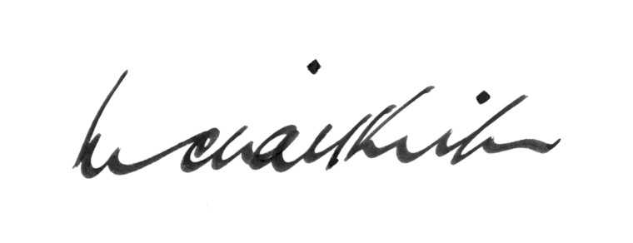

Michael Kirby
Justice of the High Court of Australia

FOREWORD

CAREER FAQS

