SOUTHERN CROSS UNIVERSITY
CENTRE FOR LAW, POLITICS AND CULTURE

OUT OF THE SPOTLIGHT: CITIZENSHIP AND PARTICIPATION OF PEOPLE WITH DISABILITY IN REGIONAL AND RURAL AREAS

MESSAGE OF WELCOME

The Hon Justice Michel Kirby AC CMG
Justice of the High Court of Australia

I was recently appointed Patron of the Centre for Law, Politics and Culture (CLPC) which is the sponsor of this conference. On behalf of CLPC and its community of scholars and students, I offer a message of welcome to the participants.

Disability, in various forms, has been the subject of law, legal cases and a measure of community progress in recent years. However, there is still much to be done and especially in regional and rural areas of Australia.

The chief target of the laws and policies concerning disability is stereotyping and invisibility. Stereotypes often prevent people from fulfilling themselves. Invisibility means that injustice and unjust inequality of treatment are ignored because they are not seen. The result is not only personal loss to those affected and their families. There is also loss to their communities, including economic loss arising from missed opportunities. See Gerard Goggin and Christopher Newell, Disability in Australia - Exposing a Social Apartheid, UNSW Press, 2005.

This conference will tackle presuppositions and assumptions about disability. It will insist that strategies (including in the law) must be grounded in empirical research, not myths, presumptions and assumptions. Encouraging all to make the most of their lives is an aspect of modern citizenship. It also happens to be beneficial for a modern economy.

I am sure that all participants in the conference will go away with enhanced knowledge and a strengthened enthusiasm to tackle issues of disability in regional and rural Australia with the benefit of research and knowledge of the progress made elsewhere in the nation and the world.

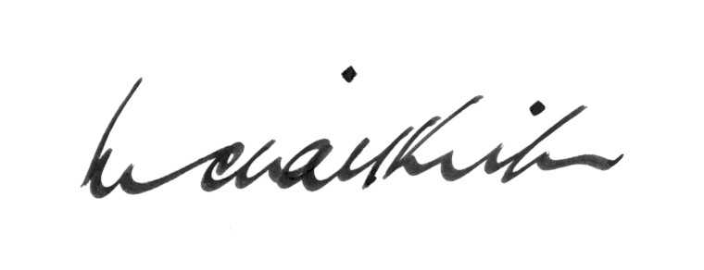

MICHAEL KIRBY
Patron of SCU Centre for Law, Politics and Culture
Canberra
12 July 2005

SOUTHERN CROSS UNIVERSITY
CENTRE FOR LAW, POLITICS AND CULTURE

OUT OF THE SPOTLIGHT: CITIZENSHIP AND PARTICIPATION OF PEOPLE WITH DISABILITY IN REGIONAL AND RURAL AREAS

MESSAGE OF WELCOME

The Hon Justice Michel Kirby AC CMG
Justice of the High Court of Australia

