SYDNEY UNIVERSITY LAW SOCIETY

BLACKACRE 2002

FOREWORD

The Hon Justice Michael Kirby AC CMG

Justice of the High Court of Australia
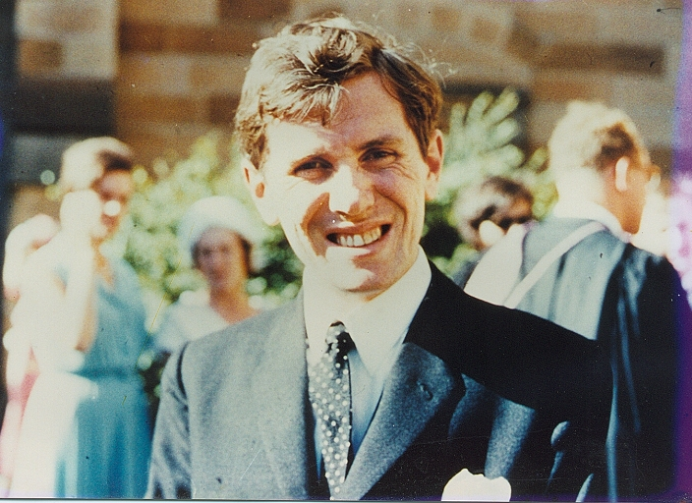
Michael Kirby in Law School Dats

I owe a lot to the Sydney Law School and the Law Society of Sydney University. After a fashionably unprosperous childhood and abstemious adolescence, I was accidentally elected to the governing body of the Society when I was absent from lectures one day.

The young Murray Gleeson, who was in the class, nominated me for a lark because I was so shy. He declares that introducing me to student politics was like introducing Henry VIII to matrimony. With that comment he came closer to the mark than he thought. In my case, student politics was the antidote to matrimony. I threw myself into the students’ causes, carrying along with me the young men and women at the Sydney Law School in the 1960s who now occupy positions of influence and power throughout our country. If I close my eyes I can see the young John Howard, the petite Bronwyn Bishop and all the great judges and silks of today’s age – mere law students, full of dreams and hopes and loves and occasional ideals.

I am glad there is a renewed interest in the history of the Law Society. It was in my time that we manoeuvred Mr Justice Manning (later Sir Kenneth) out of the President’s seat. This action, done for the noblest of causes (increased pay for articled clerks), had the not unintended consequence of my own ascent to that high office. Ever since then a student, not a judge, has been the president. It was a coming of age in a highly deferential time. For me, it was a taste of leadership and the power to do new things.

If you look around the Law School now, astonishing as it may seem, you will see the leaders of the nation, in government, law, business and politics, of twenty and thirty and forty years on. Now are the years when knowledge is accumulated, institutions learned, values collected and skills fashioned that last a lifetime.

In my day, there was no mention of equal opportunity for women – whether in society or in our profession. There was no mention of equal rights for gays and lesbians or other sexual minorities – they were an abomination. Refugees or “refos” as we called them, were regarded by many with amused contempt. White Australia still flourished as a bipartisan national objective. There were the faintest glimmerings of concern about Aboriginals. But the prospect of anything like Mabo would have been regarded as laughable – the dreamings of legal adventurers and activists. We were about to join the Americans in their war in Vietnam.

Look around you today and ask yourselves about the causes of the law, and of the world, that will make your law school days seem so old fashioned when you look back on these times in forty years to come. Causes that will make my writings in the High Court, and those of other judges of today, if ever you stumble upon them, seem so out of date and disconnected from the then reality of Australia and its laws.

The secret gift of prophecy is ventured to those who get a glimpse of the future before others do and before the future arrives for the rest. In the law, we usually build the future on the foundations of the past. It is not, mind you, the letter of the past but its spirit that is our guide. That is why Justice Windeyer was such a great Justice of the High Court, although at the time we law students did not see this. He knew that great principles lay hidden in the treasure of the laws past – but would only be revealed when their essence was discovered, the principles refined and all the verbiage cut away.

I hope that by thinking about the past of the Sydney University Law Society and by revelling in the glories of the present Law School, the students of today will catch a glimpse of the future. And that it will be a future of high ideals of equal justice under law for all.

Canberra, February 2003

SYDNEY UNIVERSITY LAW SOCIETY

BLACKACRE 2002

FOREWORD

The Hon Justice Michael Kirby AC CMG

Justice of the High Court of Australia

